**Project Report**

|  |  |
| --- | --- |
| Project Title | Design and Develop a website portal using Liferay |
| Qualification Name (NICF) | Advanced Certificate in Web Development using Platforms |
| Product Name | Triple-A (AAA) Company |
| Module Name (NICF) | Web Development using Platforms |

|  |  |  |  |
| --- | --- | --- | --- |
| Student name | | Assessor name | |
| Darren Farrell | |  | |
| Date issued | Completion date | | Submitted on |
|  | 27/04/2023 | | 27/04/2023 |
|  | |  | |
| Project Title | Design and Develop a website portal using Liferay | | |

|  |
| --- |
| Learner declaration |
| I certify that the work submitted for this assignment is my own and research sources are fully acknowledged.    Student signature: Date: 25/04/2023 |

**Content**

1. Project Background
2. Project Objectives
3. Task 1
4. Task 2
5. Task 3
6. Task 4

**Project Scenario:**

Triple-A (AAA) company is the best web host solutions service company located in downtown of Myanmar. It provides all types of services which include domain name registration, Shared Hosting, Reseller Hosting, Cloud Hosting, VPS Hosting, Dedicated Hosting, and Colocation service, etc.

**Project Objective:**

The objective of this project is:

* Create a AAA company services website using Liferay
* Develop a customer data management application using Liferay service builder
* Create a class diagram for the application structure with draw.io
* Identify the design patterns best use in this application
* Assign 2 users for administrator and site member and define their permission

**Tools and platform used**

* Liferay portal



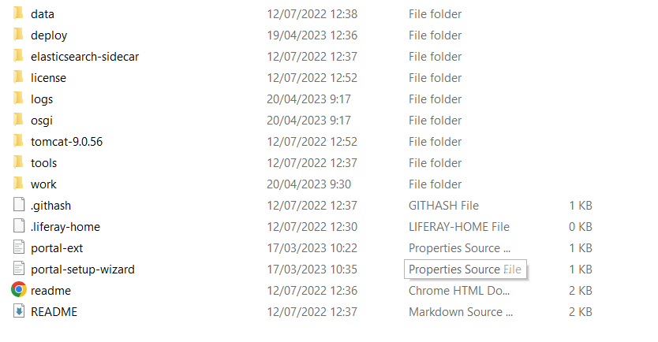

* Liferay developer studio



* Draw.io



* MySQL server and workbench

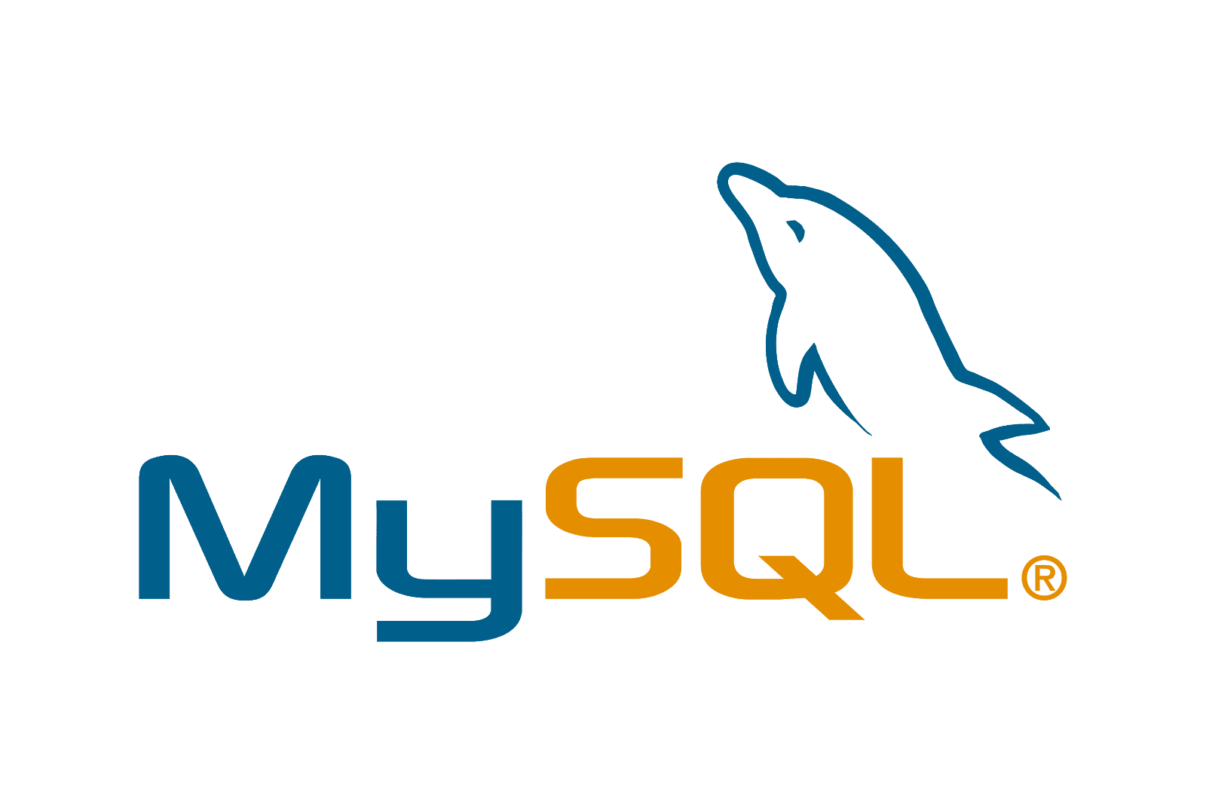

* Microsoft word and power point



**Functional Requirements**

The AAA website consists of the following Key pages

1. Home Page

2. Registration Page

3. Login Page / Sign In

4. Our services Page

a. Domain name service page

b. Shared Hosting service page

c. Reseller Hosting service page

d. Cloud Hosting service page

e. VPS Hosting service page

f. Dedicated Hosting service page

g. Colocation service page

5. Contact us Page

6. About us Page

7. Terms and Conditions Page

Customers can purchase their services from AAA’s branch offices and needs to provide personal information such as name, email, address, national identity card number and contact number. Customers' data is a very important factor for AAA Company. To maintain and manage all of their customer information, AAA has been decided to develop an application with an object-oriented approach.

An application is required to keep track of their customer’s info and services given to customers. The well-organized customer data can help the company to select the correct recipients for promotions and new services.

The Scope of the Project is to build a Liferay Framework website with customer’s data management application.

The overview of the project is as below There are two types of users in this portal.

They are 1. Administrator 2. Site Member (Staff)

Administrator should be able to perform following functions in the portal,

1. Manage all of the site contents and pages.

2. Update the theme and layout.

3. Manage the customer data portlet and control permission.

4. Manage all user (Site Member and Customer) roles and permission

Site Member should be able to perform following functions in the portal,

1. Update AAA company site contents.

2. Add and Update the AAA’s customer data.

**Task 1**

**Program Paradigm and Design Pattern**

**1.** Identify and explain the characteristics of the object-orientated paradigm and relationship between the various classes from a given code scenario

**(a) Explain briefly Object-Oriented Programming Paradigm.**

Object-Oriented Programming (OOP) is a popular programming paradigm that centers around the concept of "objects". Objects in OOP are instances of classes, which serve as blueprints or templates for creating objects. Each object possesses a unique set of properties and methods that define its behavior. there are some fundamentals principles of OOP which is Encapsulation, Inheritance, Polymorphism, and Abstraction. Those principle are the building blocks off OOP concept. Object oriented programming is a modern programming paradigm that promotes reusability and maintainability. It is widely used in industry standard languages such as C++ and java

**(b) Examine characteristics of Object-Oriented Programming Paradigm**

i. Encapsulation:

Encapsulation is one of the fundamental principles of OOP that allows data to be hidden which will protect the data from other objects or functions. Encapsulation is done by creating objects that have private data members, which can only be accessed by the methods or functions within that object. This helps to ensure that the data is not interfering with other objects this also helps to maintain the integrity of the object's internal state.  
  
Here we have a class called BankAccount which has a private variable balance

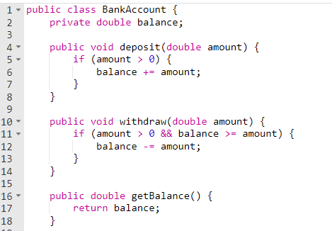

The method inside the BankAccount class can directly use the variable balance in their body but if we try to use the variable outside the class it won’t be recognized. We need to use the getter to access the data in the balance variable

Here is the main class with only variable balance

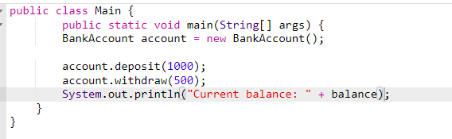

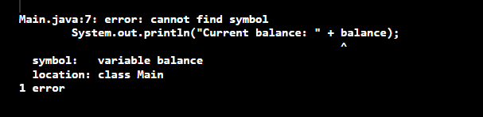

Here is the main class using the getter method in the BankAccount object

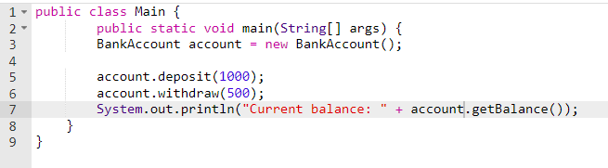

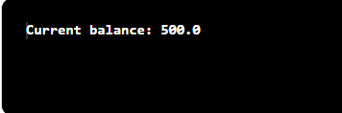

ii. Polymorphism  
this principle allows objects to take on different forms or behaviors. By using inheritance, a child class can inherit methods and properties from its parent class and even override or extend those methods to create new behaviors. This also means that objects of different classes can be treated as if they were the same type, giving you greater flexibility in code design.

Here is an example

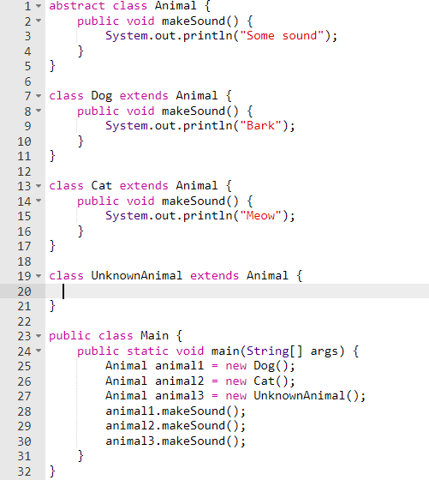

The Parent class which is Animal is being inherited by 3 subclass or childclass. The Cat and Dog which inherits from Animal has the makeSound() method by default but they sound differently the cat meows while the dog barks and there is also a third class which is an unknown animal and we does not know what it sounds like so it uses the default animal makeSound() method

iii. Constructors and destructor

Constructors and destructors are crucial aspects of OOP. Constructors set up an object's data members when it's first created, while destructors clean up any resources it used. With overloaded constructors, multiple versions of the constructor can be created, each taking different parameters. These tools provide developers with flexibility and control over object creation and management.

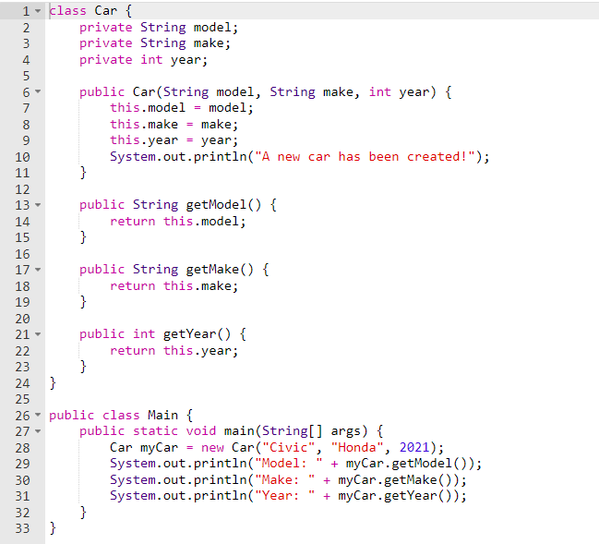

The constructor is the data in which first created in this case it’s the model, make and the year

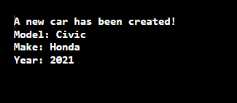

iv. Abstract

The abstract principle is a key element of OOP that helps define classes and methods. It prohibits the direct instantiation of such classes and methods and instead requires implementation by child classes. This is facilitated by the creation of abstract classes that have methods without implementation details. To make functional objects, child classes must implement these methods. By using abstract classes and methods, developers can ensure that code is reusable and scalable while maintaining consistency and structure.

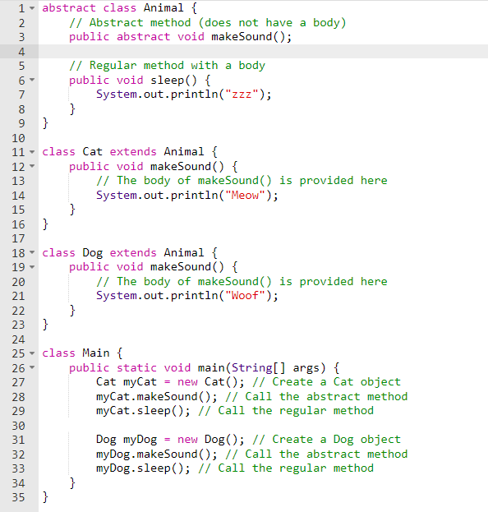

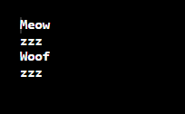

v. Interface

The interface principle, while similar to the abstract principle, is used to specify a set of methods that a class must implement, as opposed to an entire class structure. Interfaces are employed to establish agreements between objects, ensuring that they are able to interact with each other in a predictable manner. This principle is especially critical in extensive software development projects where numerous objects may require interactions with each other in intricate ways.

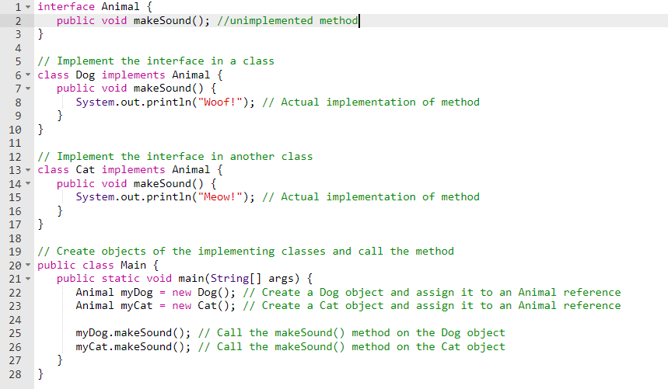



vi. The differences between abstract classes and interfaces

Abstract:

* Can contain both abstract and non-abstract method
* Allow constructor
* Allows data field
* Uses the keyword extend to extend an abstract class
* A class can only inherit from one abstract class
* Abstract classes can have public, private, protected

Interface:

* Can only contain abstract method
* Does not allow constructor
* Does not allow data field
* Uses the keyword implement to implement the interface
* a class can implement multiple interfaces.
* Only public access modifiers

**(c) Examine Class Relationships using UML diagrams**

1. Inheritance:

inheritance is a concept of OOP that makes it so that a new class can use an existing class's properties and method by inheriting the existing class. This is a good concept of OOP that is useful for large-scale applications to reduce code duplication.

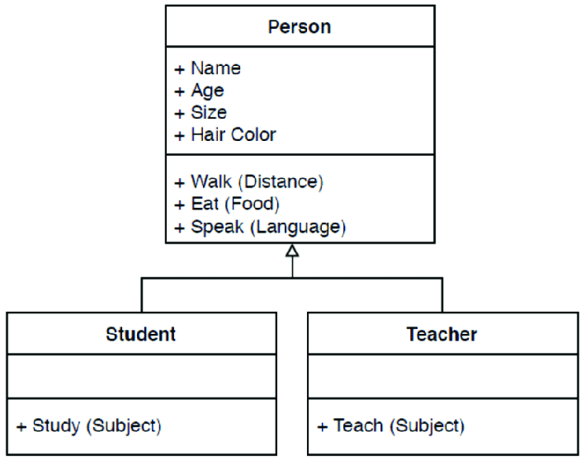

1. Realization

Realization is when an object-oriented program uses a class to put an interface into action. Interfaces tell a class which methods it needs to have. Once a class follows through on the interface, it's promised to have an implementation for each method in the interface. The result? Different classes can act as though they're the same type of object when they fulfill the same interface.

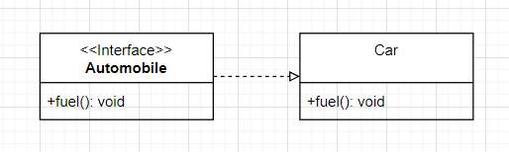

1. Dependency

Dependency is a concept used in programming to describe a relationship in where one object is reliant on another object to function. This means that the class in which the other class is dependent on is fully in relied on for the functionality the other class has. It means that if the class changes the other class has to change as well.

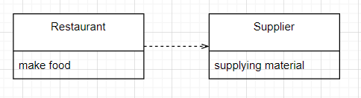

1. Aggregation

Aggregation is a term used in programming to describe a relationship between two objects, where one object "has" another object as a part of its state. Like a car object, it might have a car object as one of its components. Aggregation is a way to model objects by breaking them down into smaller, more manageable pieces.

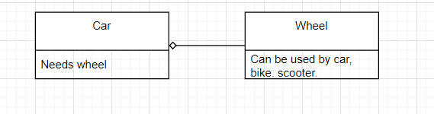

1. Composition

Composition is basically like a stricter version of aggregation. In composition, one object is composed of other objects, and the composed objects cannot exist without the parent object. This means that the parent object is responsible for creating and destroying the composed objects, and the composed objects cannot be used outside of the parent object. This is in contrast to aggregation, where the composed objects can exist independently of the parent object.

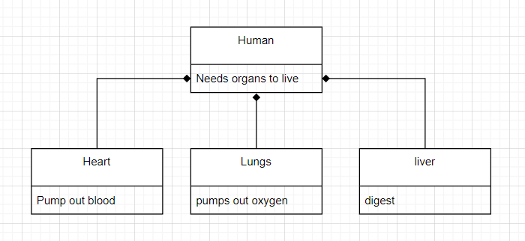

**(d) Examine and list out class relationships which are used in project scenario.**

1. Inheritance

Administrator, customer and site member have variables that they inherited from a superclass called User which contains all of the variables and method to make the administrator, customer, and site member whole.

1. Association

Admin can manage customers and site members, while site members can only handle customers which mean all of the relationship between admin and site member, admin and customer, and site member and customer is undirectional.

**2. Identity the suitable design patterns based on the project scenario.**

1. What is creational design pattern? List out creational design pattern.

Creational design patterns are a category of design patterns that deal with the process of object creation, providing a way to create objects in a more flexible, reusable, and scalable way. The purpose of creational design patterns is to abstract the process of object creation and initialization, allowing the system to be more flexible and adaptable to change.

* Factory Method: This design pattern offers an interface for producing objects, but delegates the task of object instantiation to its sub-classes. This allows the sub-classes to choose which objects to produce and makes the code more flexible.
* Abstract Factory: This design pattern provides an interface for producing related object families, without having to specify their concrete classes. This makes the system more adaptable to changes and more flexible.
* Builder: This design pattern separates the construction of a complex object from its representation. This allows the same construction process to create different representations and makes the code more modular.
* Prototype: This design pattern creates new objects by copying existing ones, which provides an easy way to create new objects with minimal effort.
* Singleton: This design pattern ensures that only one instance of a class is created and provides a global point of access to that instance.
* Object Pool: This design pattern creates a collection of reusable objects that can be shared among different parts of the code, instead of creating new objects every time they are needed. This reduces the memory usage and makes the code more efficient.

1. Identify suitable design pattern for “AAA Portlet”

The most suitable design pattern for AAA portlet is the factory method.

c) What is structural design pattern? List out structural design pattern.

Structural design patterns refer to a group of design patterns that focus on how classes and objects can be combined to create larger and more complex structures with added functionality. These patterns are primarily concerned with the relationships between classes and how they can be organized to form larger structures. By utilizing these patterns, developers can achieve more flexible and maintainable code that can easily adapt to changes in the system.

* Adapter: This pattern allows incompatible interfaces to work together by wrapping an object and exposing a standard interface.
* Bridge: This pattern decouples an abstraction from its implementation, allowing them to vary independently.
* Composite: This pattern allows objects to be treated as a tree-like structure, with individual objects and groups of objects treated uniformly.
* Decorator: This pattern adds functionality to an object dynamically, without changing its underlying structure.
* Facade: This pattern provides a simplified interface to a complex system, making it easier to use and understand.
* Flyweight: This pattern shares objects to reduce memory usage, by reusing objects that are the same or similar.
* Proxy: This pattern provides a placeholder or surrogate for another object, allowing the proxy to control access to the original object.

1. Identify suitable design pattern for “AAA Portlet”

The most suitable design pattern for AAA portlet is the Facade pattern

1. What is behavioral design pattern? List out behavioral design pattern

Behavioral design patterns are a category of design patterns that deal with the communication and interaction between objects and classes, as well as the assignment of responsibilities and behaviors to objects. These patterns are concerned with how objects and classes interact and communicate with each other to achieve a common goal.

* Chain of Responsibility: This pattern allows multiple objects to handle a request, with each object deciding whether to handle the request or pass it on to the next object in the chain.
* Command: This pattern encapsulates a request as an object, allowing the request to be parameterized, queued, and executed at different times.
* Interpreter: This pattern defines a grammar for a language and uses an interpreter to interpret and execute sentences in the language.
* Iterator: This pattern provides a way to traverse a collection of objects without exposing its underlying implementation.
* Mediator: This pattern defines an object that encapsulates the communication between a set of objects, allowing them to interact without being directly coupled.
* Memento: This pattern allows an object to capture and restore its internal state, without violating encapsulation.
* Observer: This pattern defines a one-to-many relationship between objects, so that when one object changes state, all its dependents are notified and updated automatically.
* State: This pattern allows an object to alter its behavior when its internal state changes, without changing its class.
* Strategy: This pattern defines a family of algorithms, encapsulates each one, and makes them interchangeable.
* Template Method: This pattern defines the skeleton of an algorithm in a base class, allowing subclasses to provide specific behavior for some steps.

1. Identify suitable design pattern for “AAA Portlet”

The most suitable design pattern for AAA portlet is the template pattern

1. **Examine how the object-orientated paradigm and its key principle is identified in each of the design patterns.**

Object-oriented programming (OOP) is a programming style that focuses on using objects and classes to structure code. On the other hand, design patterns refer to reusable solutions to common software design challenges.

Design patterns are built on the principles of OOP, which include concepts such as encapsulation, inheritance, polymorphism, and composition. Each design pattern uses these concepts in unique ways. For example, the Singleton Pattern uses encapsulation to make sure that only one instance of a class is created, while the Factory Method Pattern uses inheritance to let subclasses decide which objects to instantiate. The Adapter Pattern uses polymorphism to convert the interface of a class to another interface expected by clients, and the Decorator Pattern uses composition to dynamically add functionality to an object. The Observer Pattern uses abstraction and encapsulation to create a one-to-many relationship between objects.

In summary, design patterns illustrate how the object-oriented paradigm can be used to create modular, reusable, and maintainable code. Design patterns and the object-oriented paradigm complement each other, with design patterns demonstrating the advantages of object-oriented principles and providing insights into how they can be applied to real-world issues.

**Task 2**

**System Design**

**1. Design and build class diagrams based on project scenarios using a UML tool.**

1. **Draw Class Diagrams showing Class-relationships**

What is class diagram:

A class diagram is a graphical representation of a system's structure that shows the relationships between classes, interfaces, and other elements. It is a type of UML diagram used to specify, visualize, and document the design of a software system. A class diagram typically displays the name, attributes, and methods of each class, as well as any relationships between classes such as inheritance, aggregation, and association. It is useful for understanding the system's structure and communicating it to others involved in its development.

**Base on the scenario, define the classes, attributes, and methods**

|  |  |  |  |
| --- | --- | --- | --- |
| **Classes** | **Purpose** | **Attributes** | **Methods** |
| Administrator | 1. Manage all of the site contents and pages.  2. Update the theme and layout.  3. Manage the customer data portlet and control permission.  4. Manage all user (Site Member and Customer) roles and permission | Inherit from Users | manageSites()  managePermissions()  manageUsers()  manageCustomer() |
| Site Member (Staff) | 1. Update AAA company site contents.  2. Add and Update the AAA’s customer data. | Inherit from Users | addCustomer()  updateCustomer() |
| Users | Describes the two user categories in the AAA Company | aaa_userId  aaa_userName  email  password | manageContents(), register(), login(), logout() |
| Customer | Buy the service | customerId, customerFirstName, customerLastName, customerEmail, customerAddress, contactNumber,  customerNRIC, aaa_startDate  serviceName | buyService() |

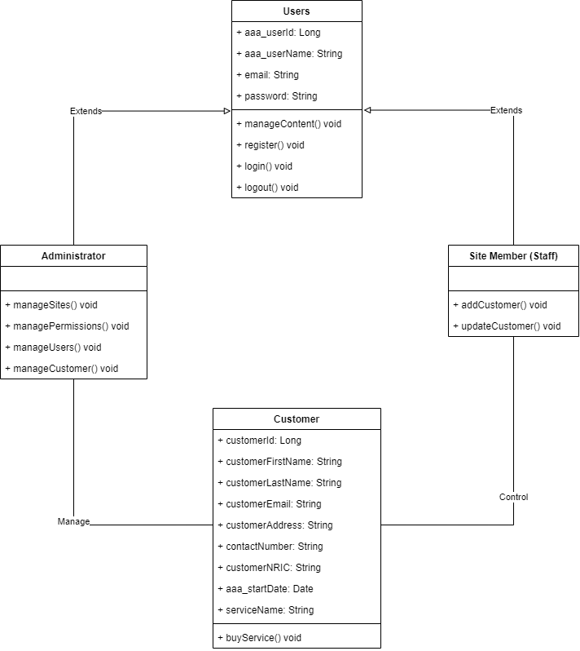

**(b) Explain relationships between classes in No.(a)**

In the AAA company hierarchy, there are two types of users - Administrators and site members. These two classes share common attributes such as name, email, and similar functionalities for managing content, registering, logging in, and logging out. Therefore, both of them are subclasses of the superclass Users, which is represented by a solid line with a hollow arrowhead in the class diagram. As Administrators are responsible for managing customers, there is a solid line relationship between Administrator and Customer classes in the class diagram. Site members also interact with customers since they are responsible for managing them, which is why this relationship is important to represent in the diagram. The class diagram highlights the relationships between the different classes in the AAA Company and how they are interconnected. The use of inheritance and relationships between classes is an important aspect of object-oriented programming that helps to create efficient and organized software systems.

**2. Identify possible situations where design patterns would be beneficial and then develop the UML diagrams reflecting the design patterns.**

* The Factory Method pattern is a useful technique for creating objects in software development. The getInstance() method, located in the serviceContext Factory class, is a reusable function that creates the necessary serviceContext object for updating a customer's user ID. When users interact with the Customer Portlet, they can rely on the factory to create a serviceContext object without understanding the complex creation process.

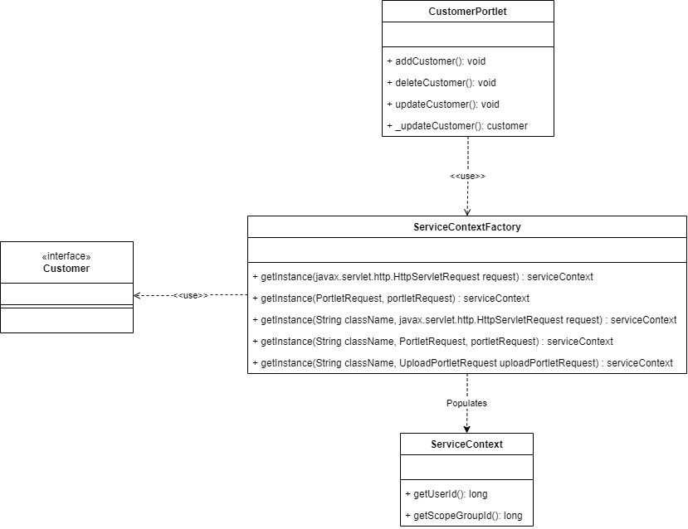

* The Facade design pattern is a useful technique for simplifying complex systems. In the context of software development, the CustomerLocalServiceUtil class serves as a façade class, providing a common interface for users to execute CRUD operations and implement company business logic through the CustomerPortlet.

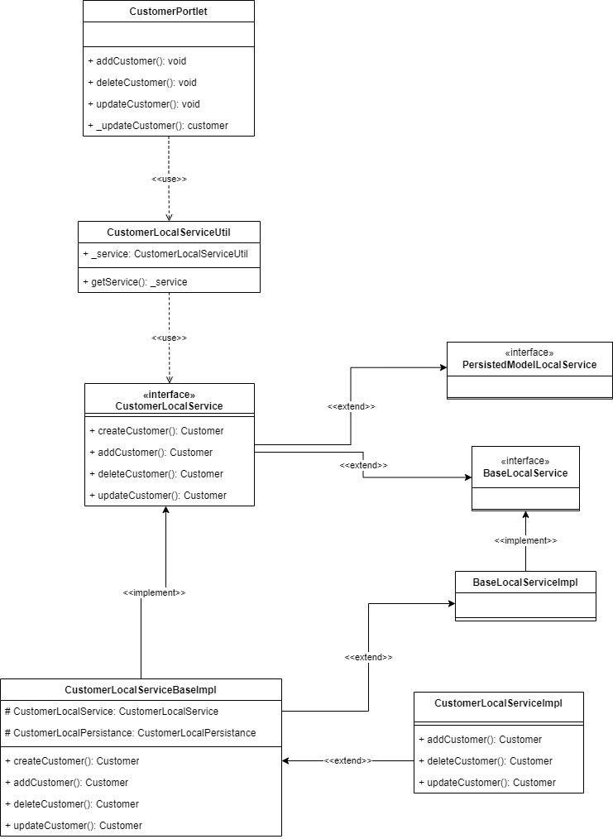

* The Template Method design pattern is a valuable design pattern for creating reusable code that can be adapted to suit different situations. In the case of the Customer Portlet, the structure of the Abstract GenericPortlet is utilized, allowing some of its methods to be implemented. This enables the development of a variety of portlets, including welcomePortlet and greeting Portlet, that share a common structure.

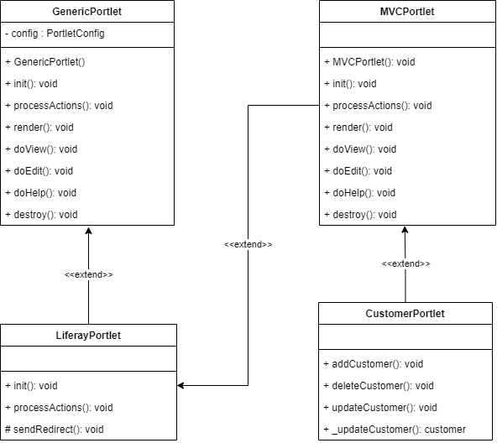

**Benefits of Design Patterns**

Developers can benefit greatly from using design patterns in their software development projects. By applying proven solutions to common OOP problems, developers can improve code reusability and create more organized and maintainable systems. Design patterns also help establish a clear system architecture, which can lead to better application development. Through the use of design patterns, developers can reduce code complexity, improve code flexibility and scalability, and foster better collaboration among team members. All in all, the use of design patterns can greatly enhance the efficiency and effectiveness of software development projects, resulting in higher-quality software products.

**3. Observe how the class diagrams are reflected from a given scenario by using the UML tool.**

The UML class diagram for the factory design pattern shows that the user can easily obtain different serviceContext objects for Customers by utilizing the serviceContextFactory or the factory class. The getInstance() method in the factory class can be reused based on the required model or object, enabling the user to retrieve the corresponding id and update the customer information with ease.

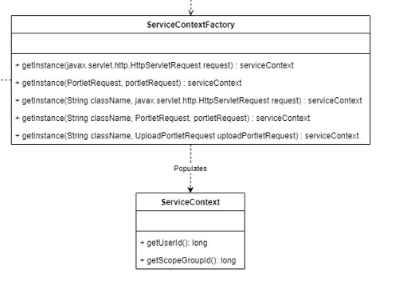

The use of aggregation in the serviceContext allows for the aggregation of relevant information, such as the method to retrieve the current user ID. This is exemplified in the ServiceContextFactory.getInstance(..) methods, where the ServiceContext is populated with information extracted from a request object.

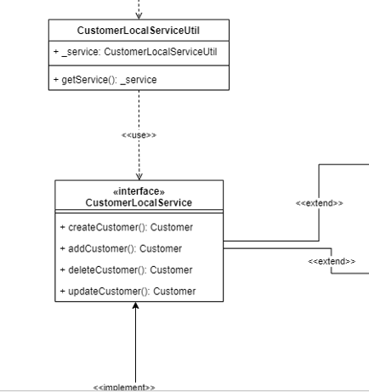

In the facade design pattern class diagram, the CustomerLocalServiceUtil class serves as a simple interface for the user to access the various methods required for managing customers and services. It relies on the CustomerLocalService interface, which defines the necessary operations for customer management, and the Util class simplifies the implementation by hiding the underlying complexity. Additionally, the CustomerLocalServicelmpl class implements the interface methods through inheritance, as it extends the super class BaseLocalService and PersistedModeLocalService. Overall, the design pattern allows for streamlined and efficient customer and service management.



The template design pattern is exemplified by the relationship between the abstract class GenericPortlet and its subclasses. The subclasses can implement their specific method without changing the structure of the abstract class, showcasing the flexibility of the template pattern.

**Task 3**

**System Development**

**1. Set up a project, build an application based on your derived UML class diagrams and design patterns. Provide screenshots as evidence.**

1. Create MVC Portlets (Customer and Service) to manage AAA customer’s

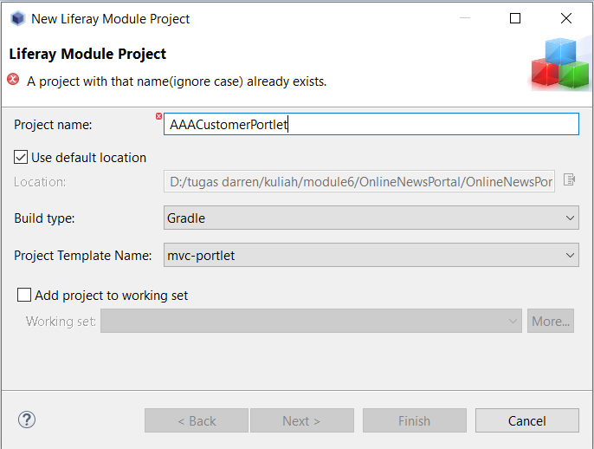Data

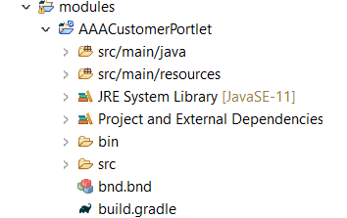

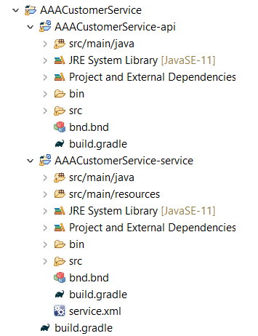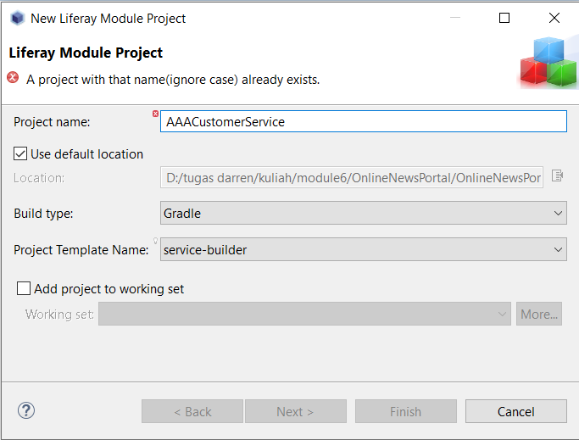

2. Build required entities using service builder.

Go to the service xml to build the required entities

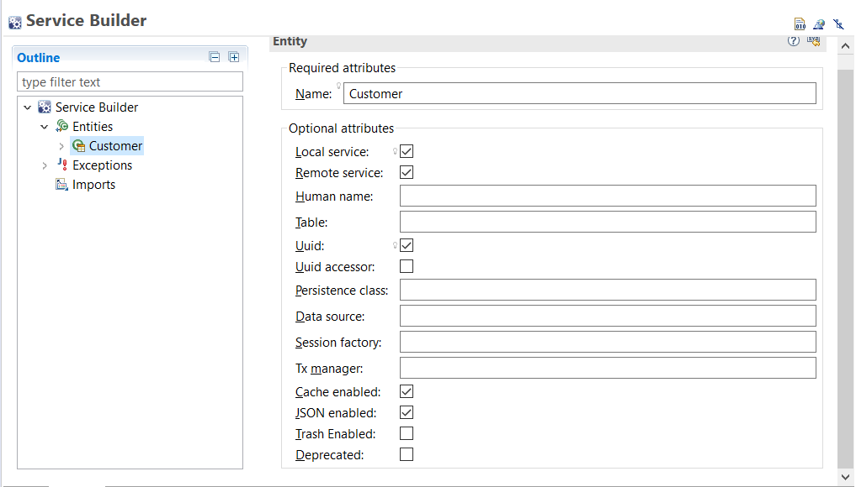

Build the column

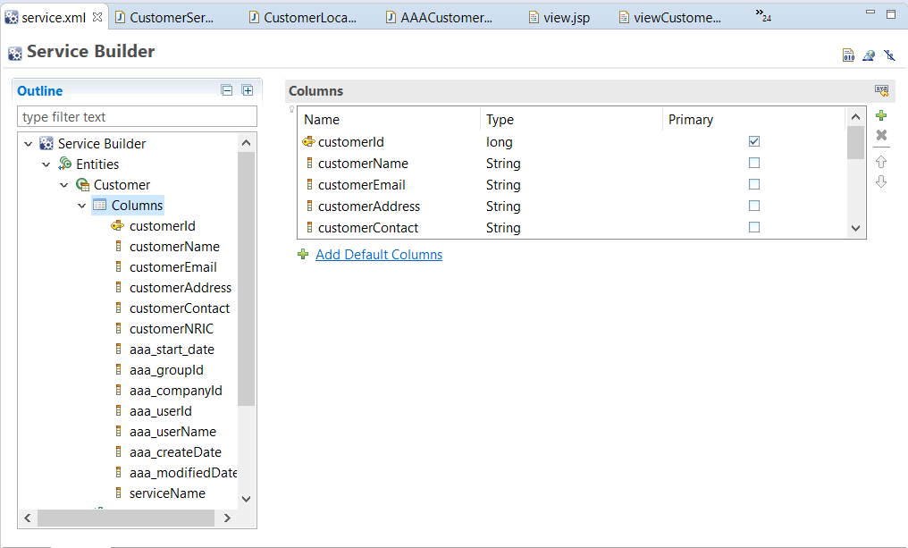

3. Provide the screen capture of service.xml

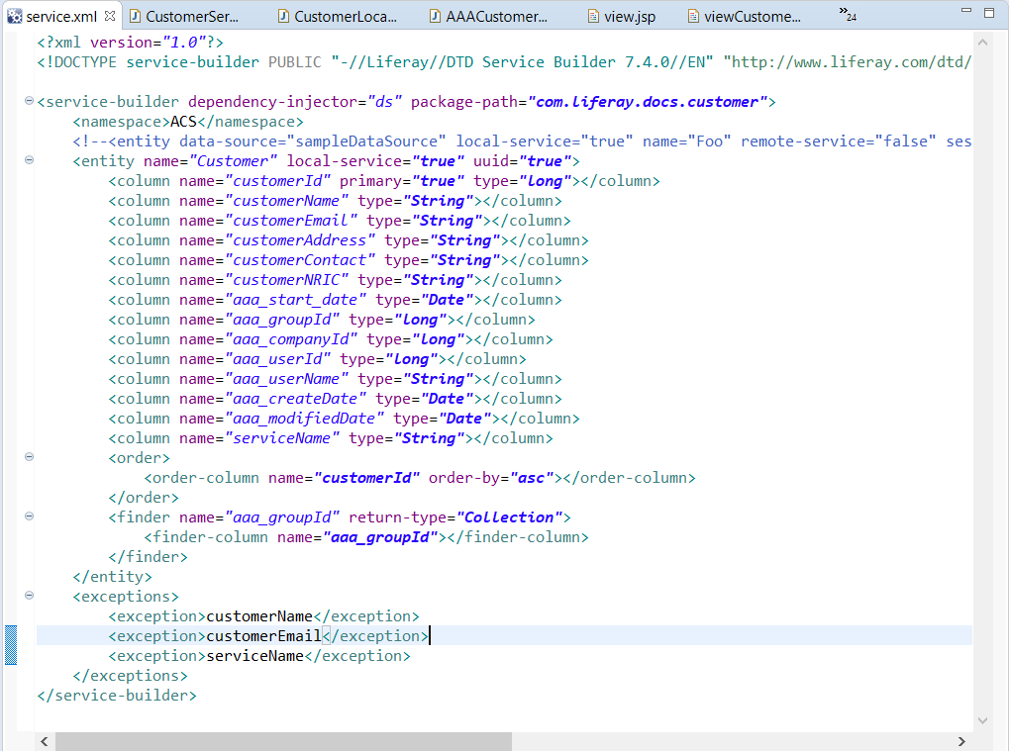

4. Provide screen capture of Service Layer

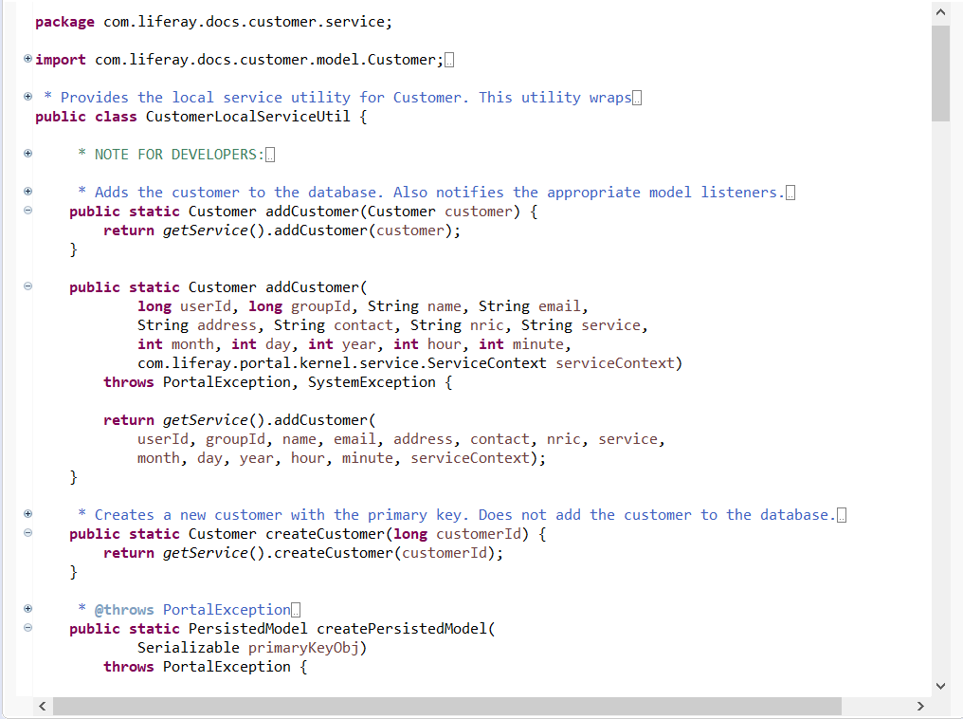

5. Provide screen capture of Controller Class

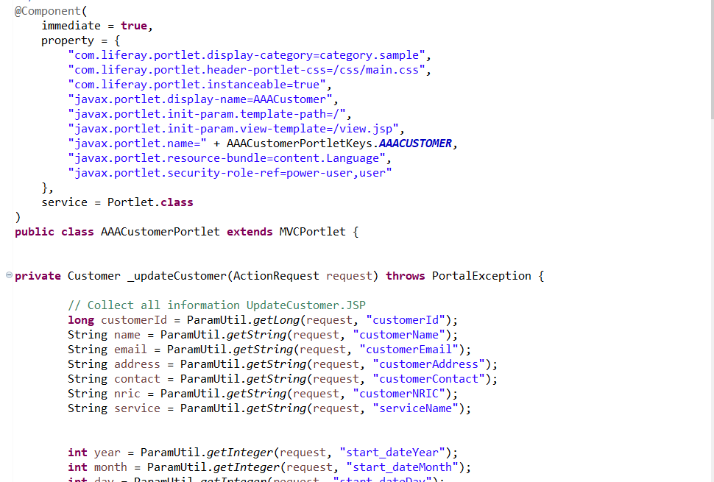

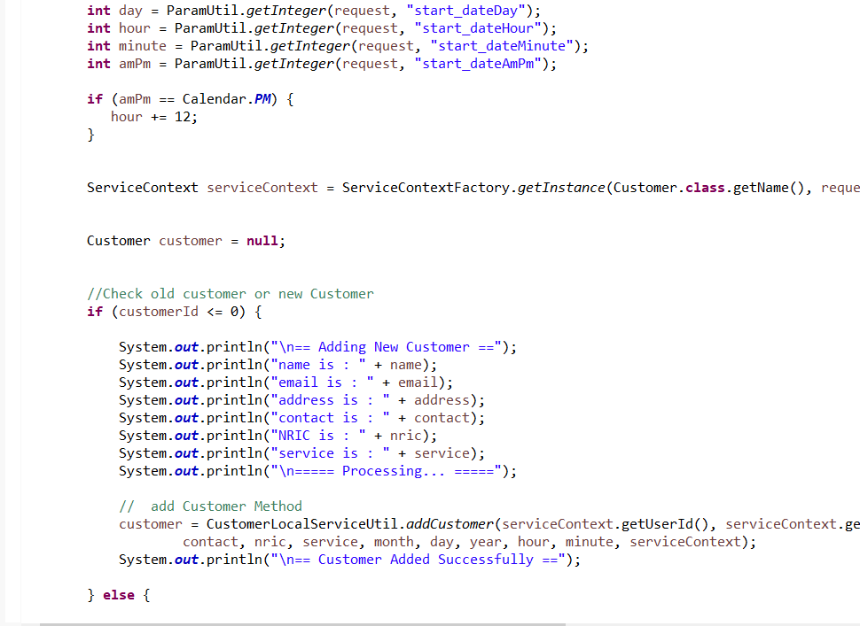

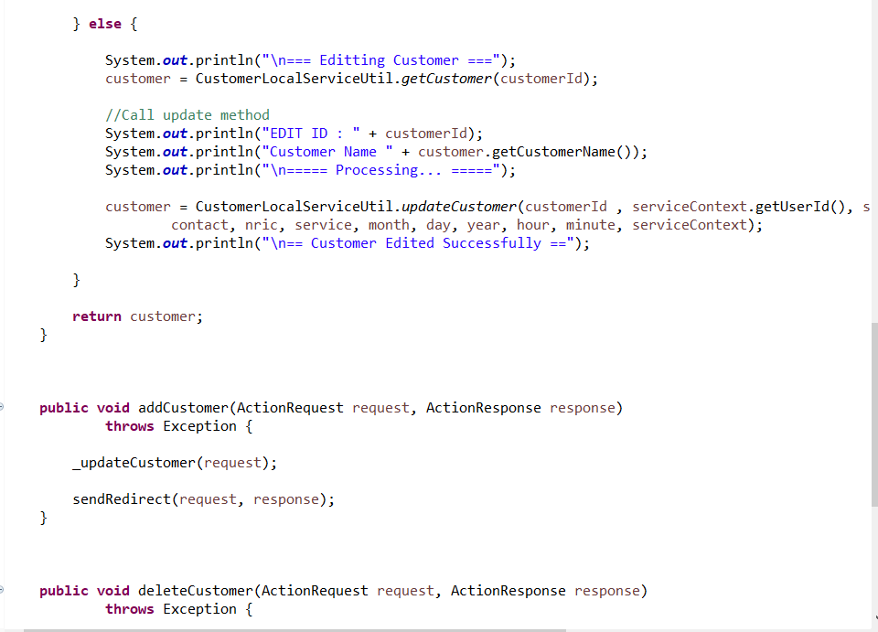

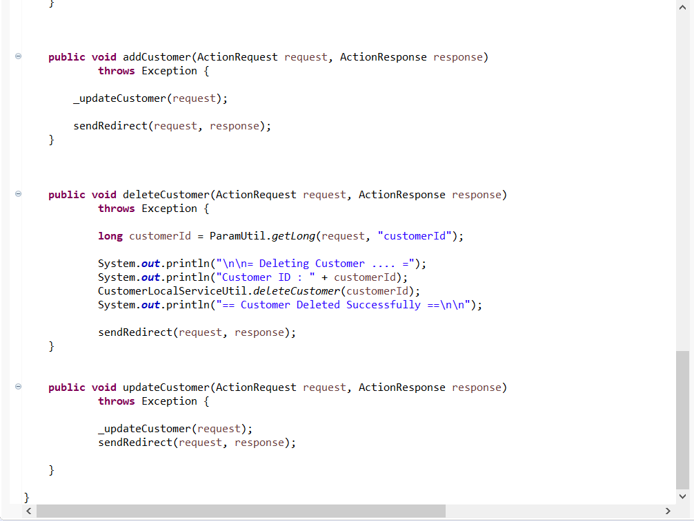

6. Provide screen capture of required jsp files for “AAA Customer and Service

Portlet”.

* View.jsp

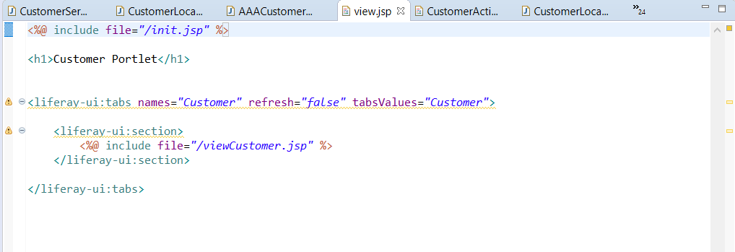

* Init.jsp

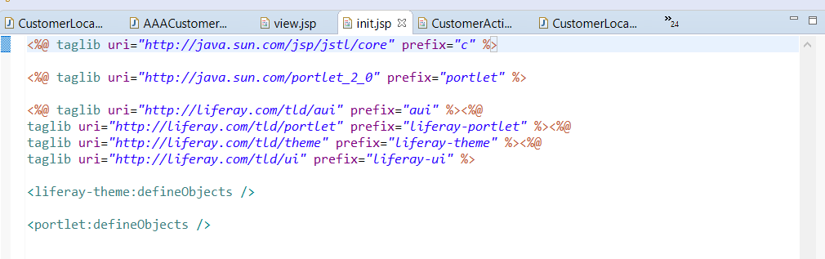

* viewCustomer.jsp

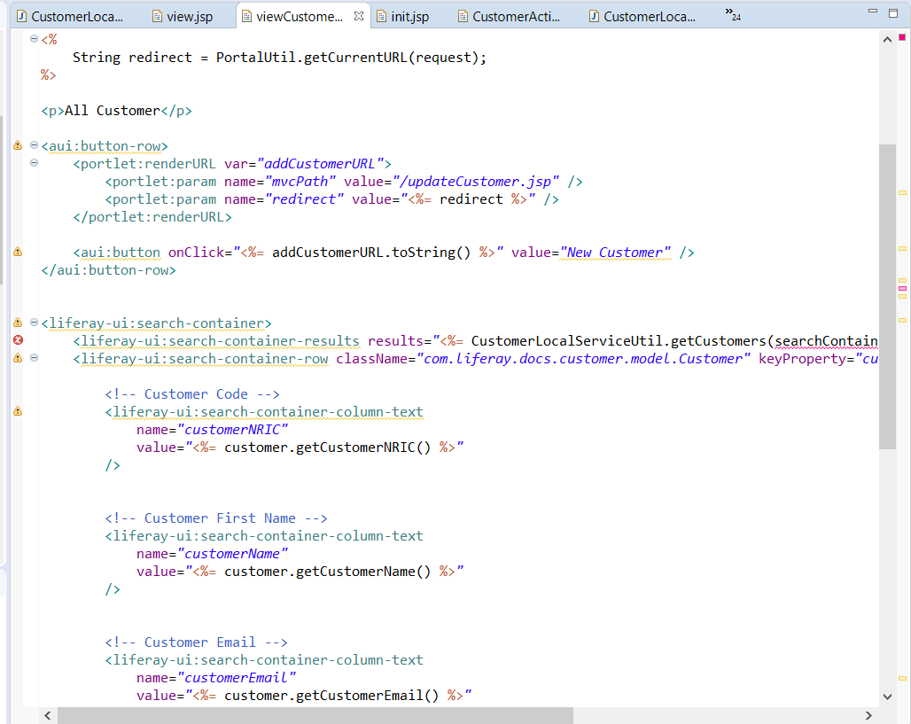

* updateCustomer.jsp

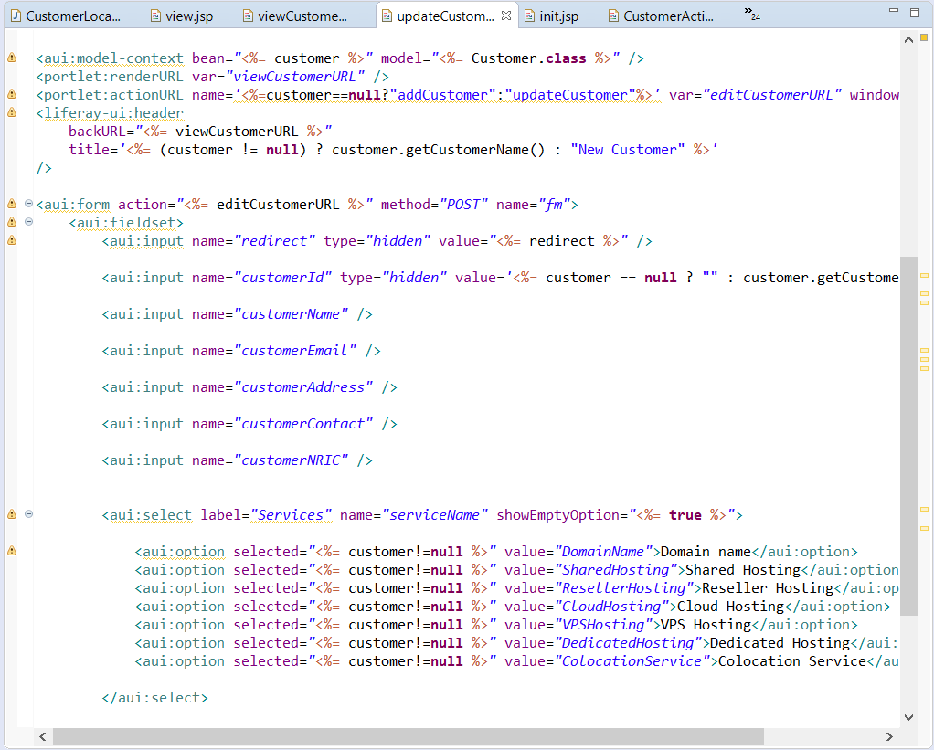

* customerAction.jsp

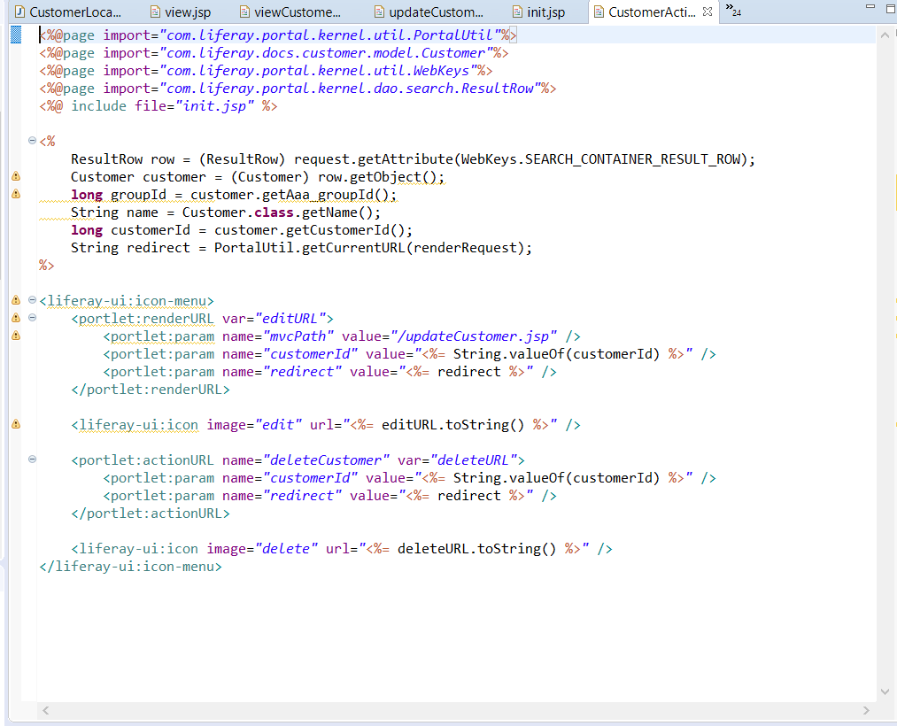

7. Create the Triple-A (AAA) company webpages. Take the screen captures of the following pages along with your Admin Account Name (Make sure that admin must be registered with Your Name)

Admin account

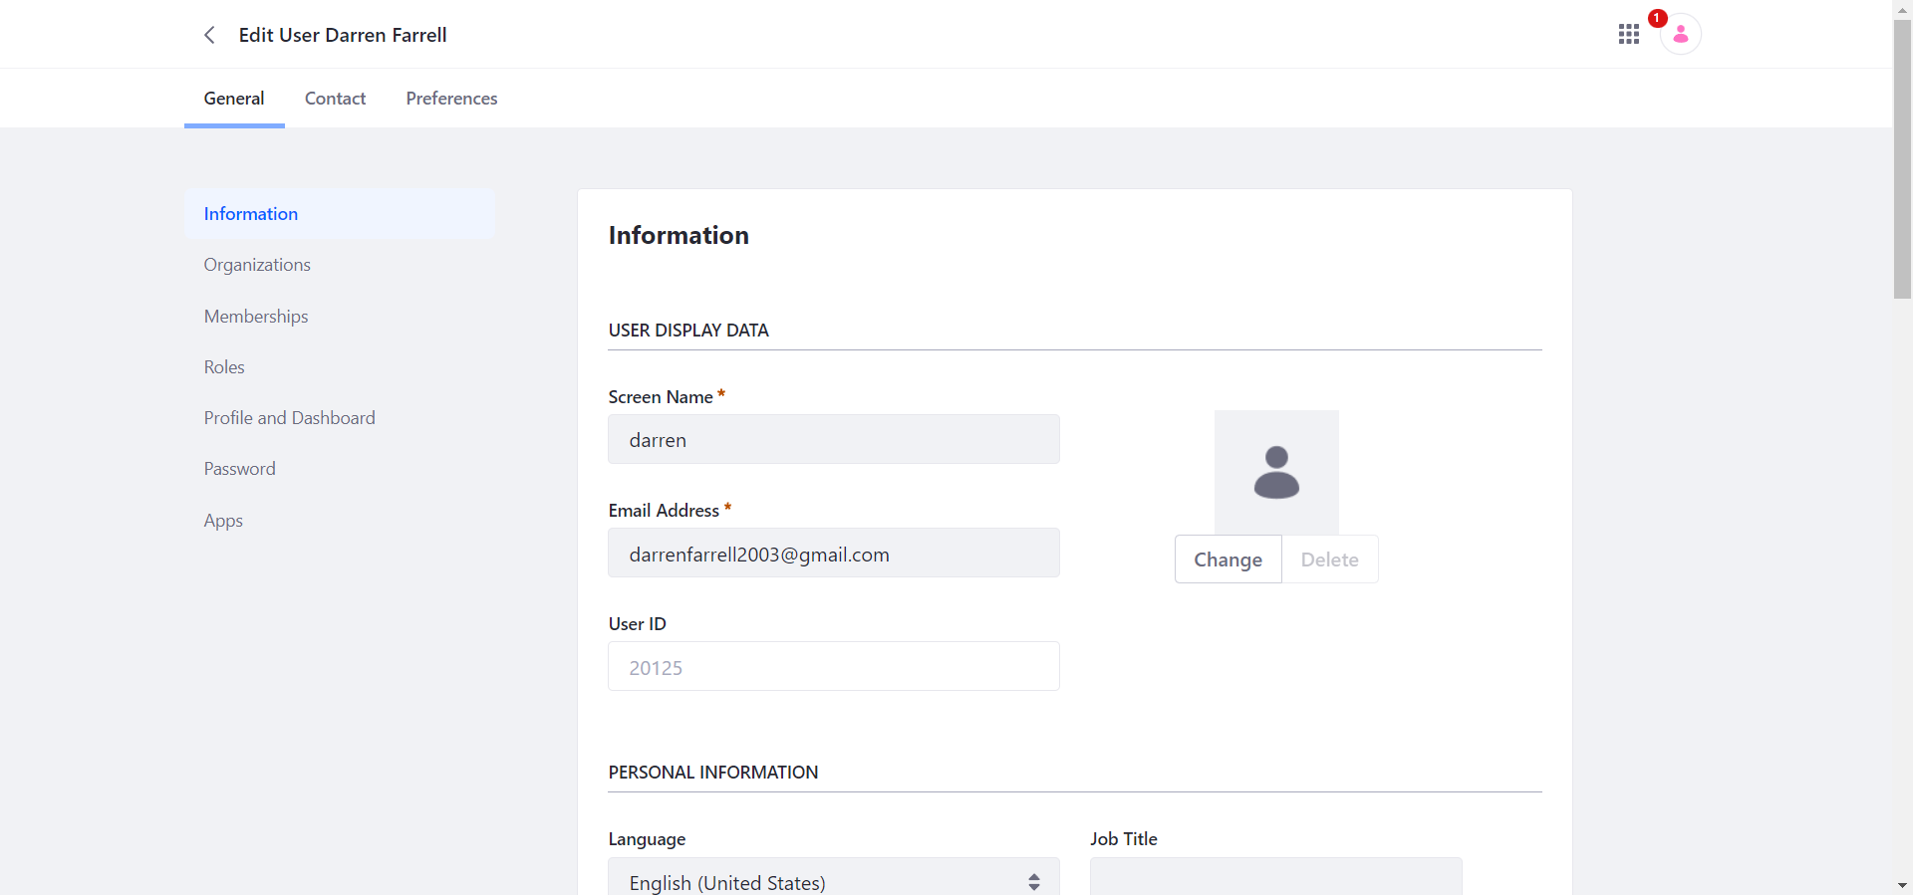

Admin Roles

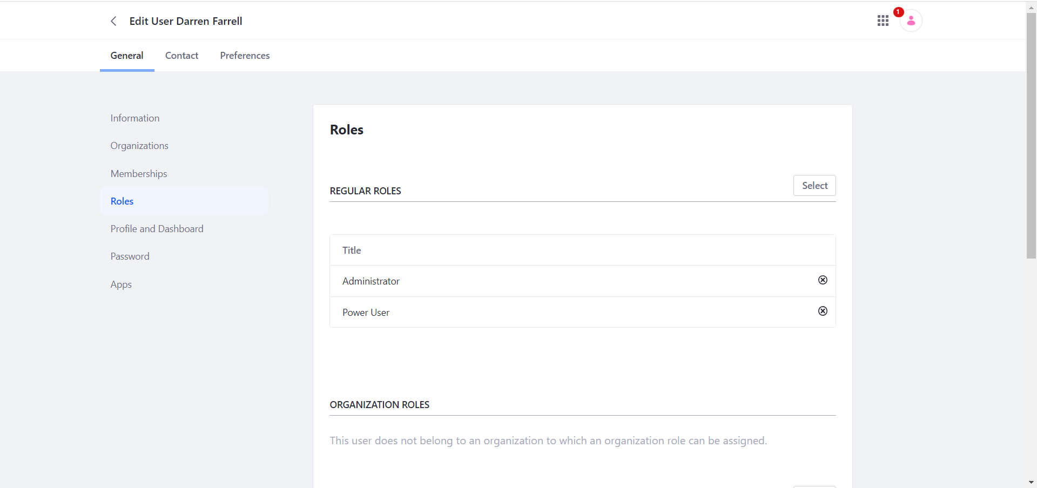

Staff account

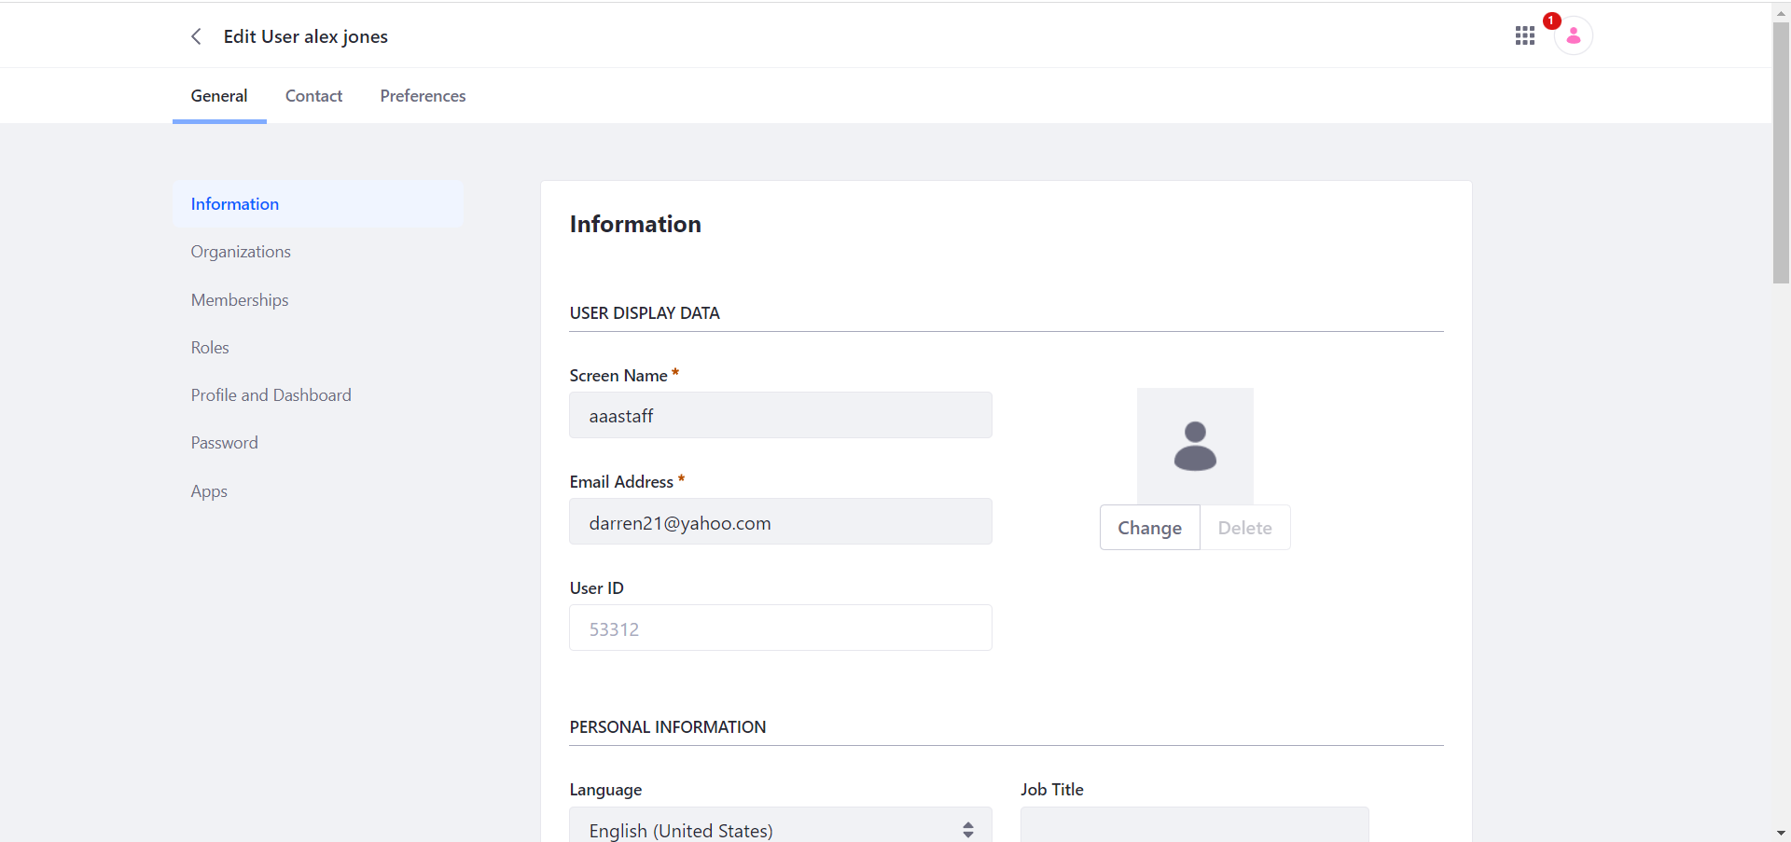

Staff roles

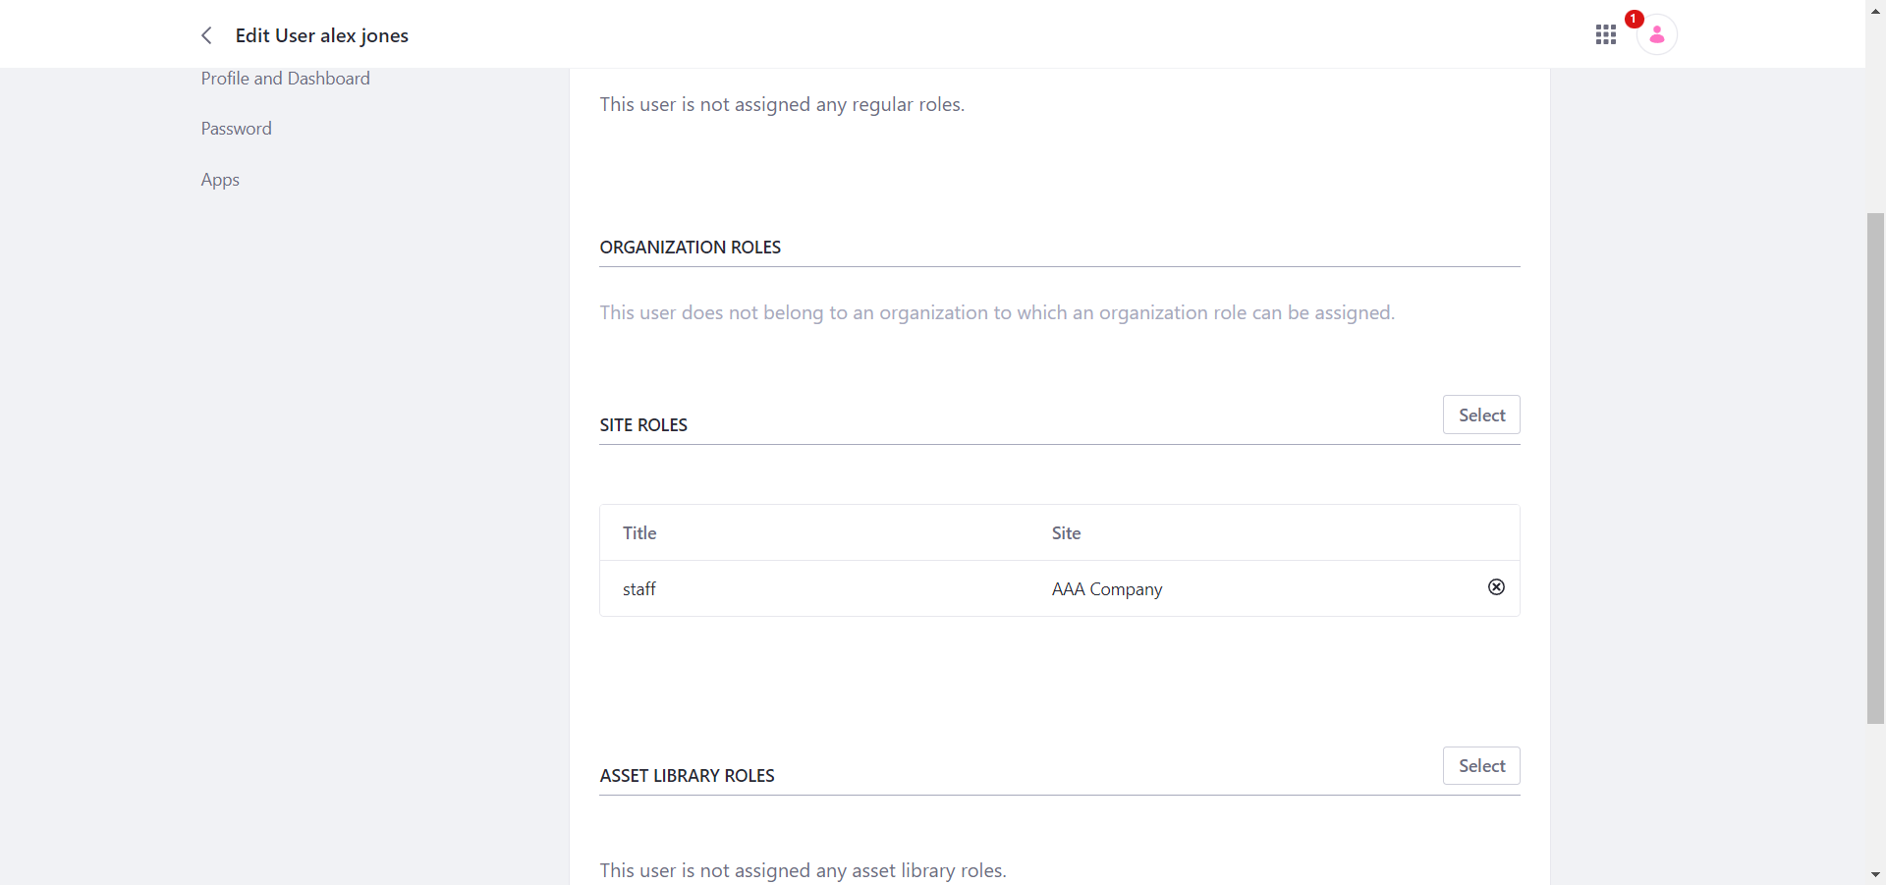

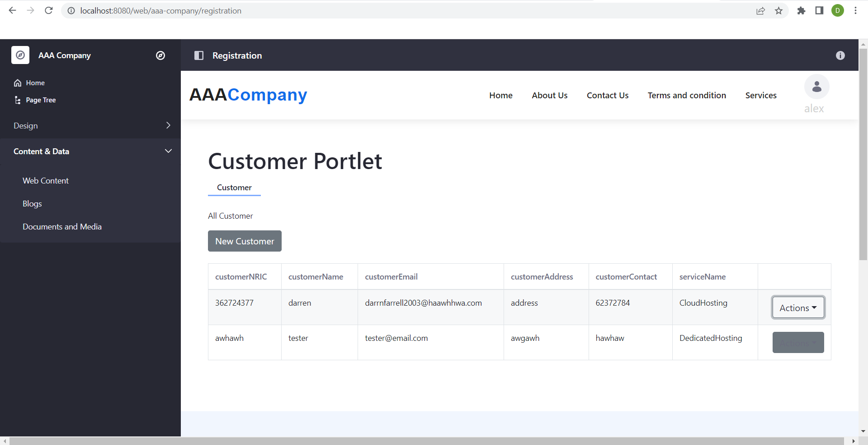

1. Home Page



1. Our Services Page (including Customer and Service Portlet)

- Domain name service

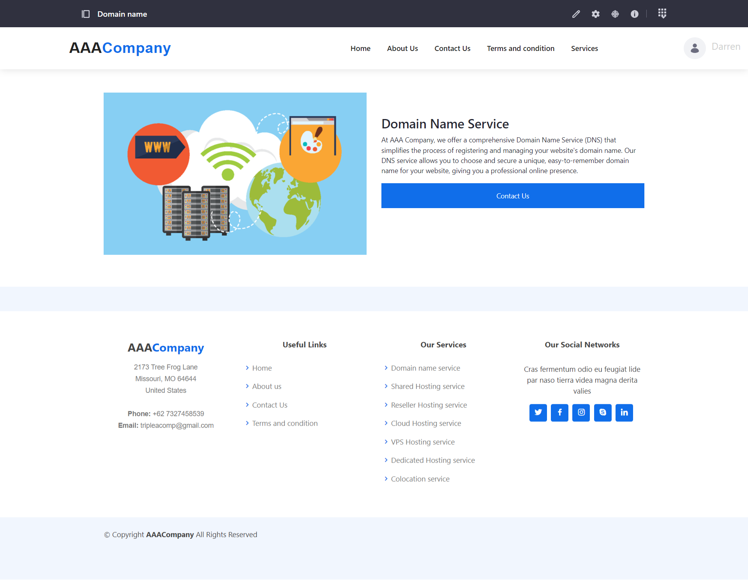

- shared hosting service

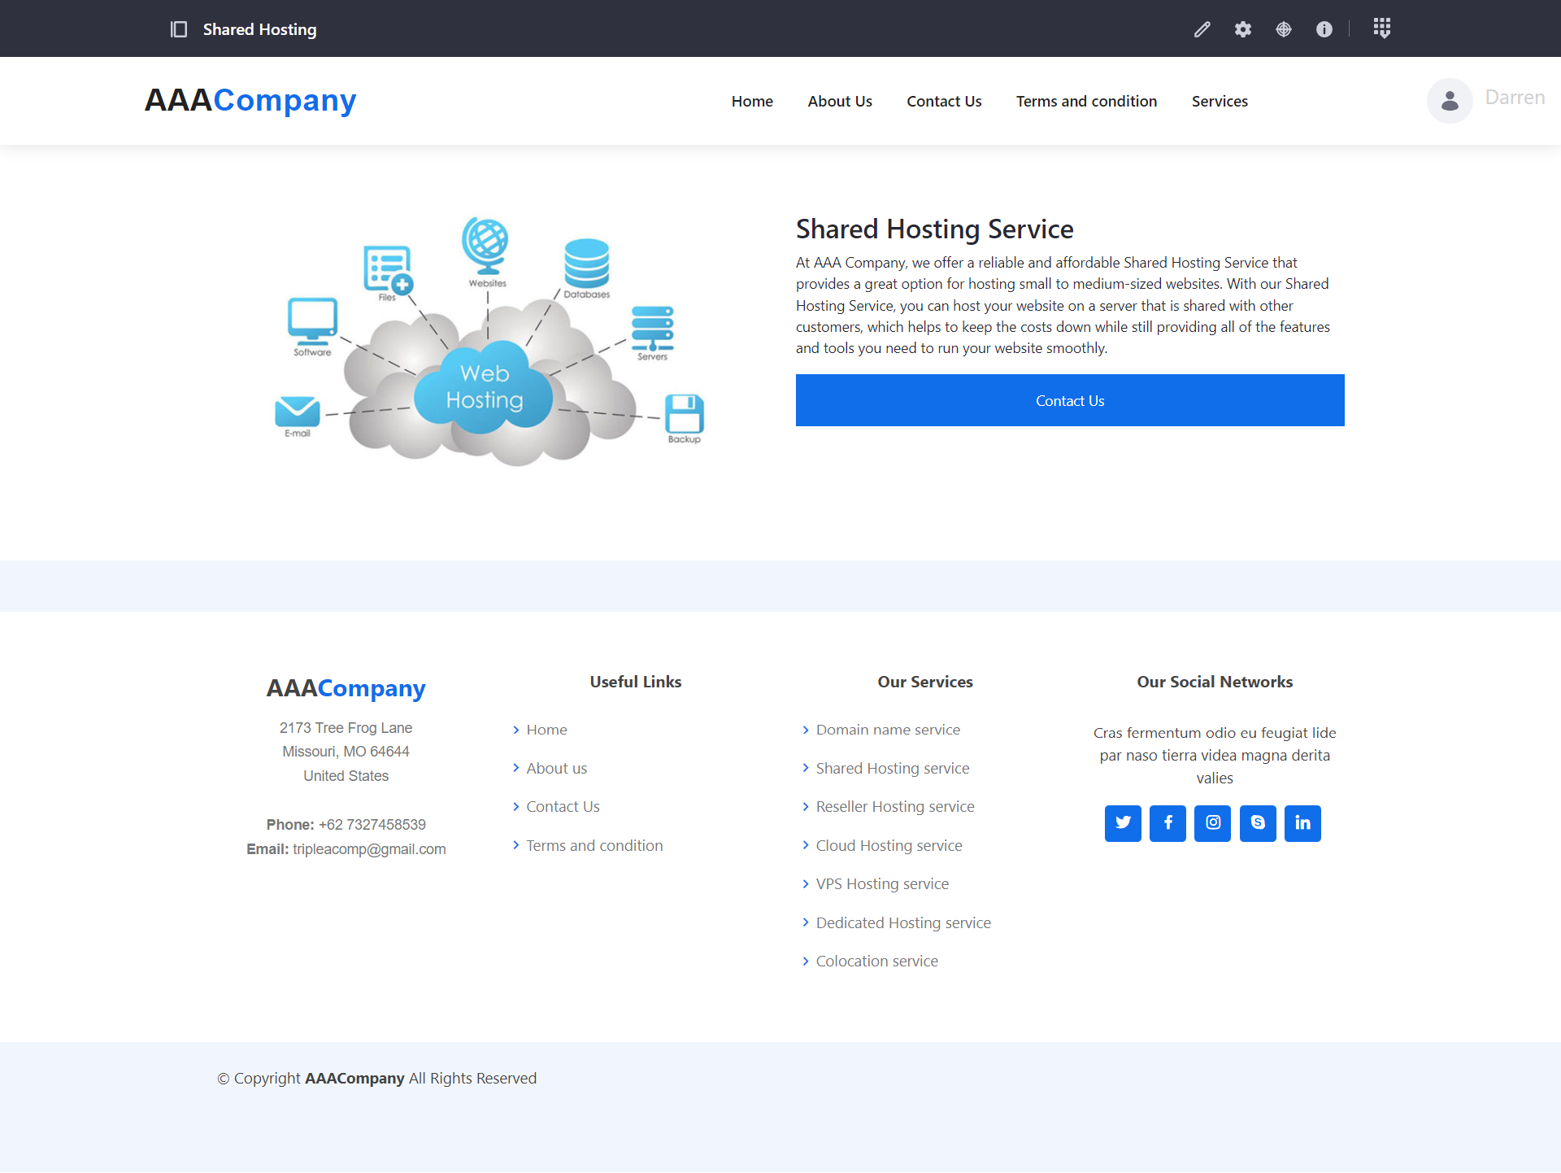

* Reseller hosting service

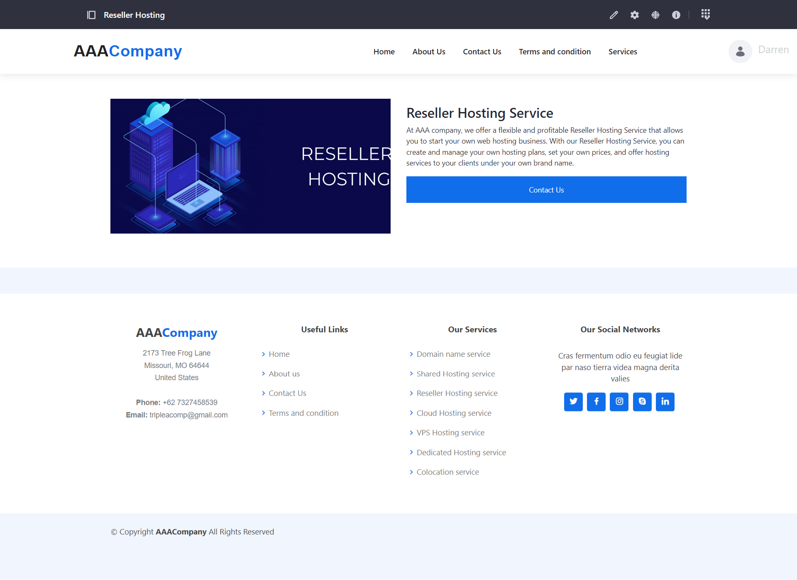

* Cloud hosting service

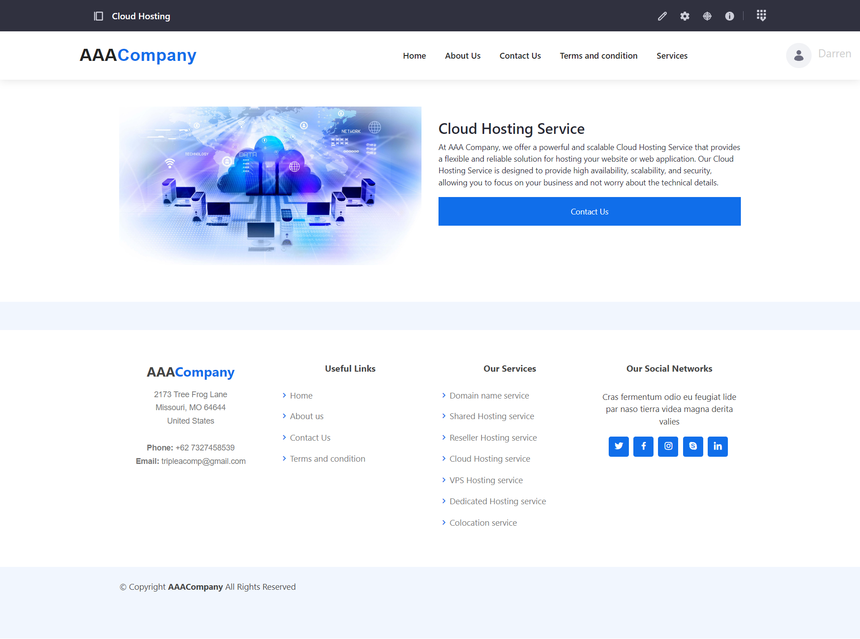

* VPS hosting Service

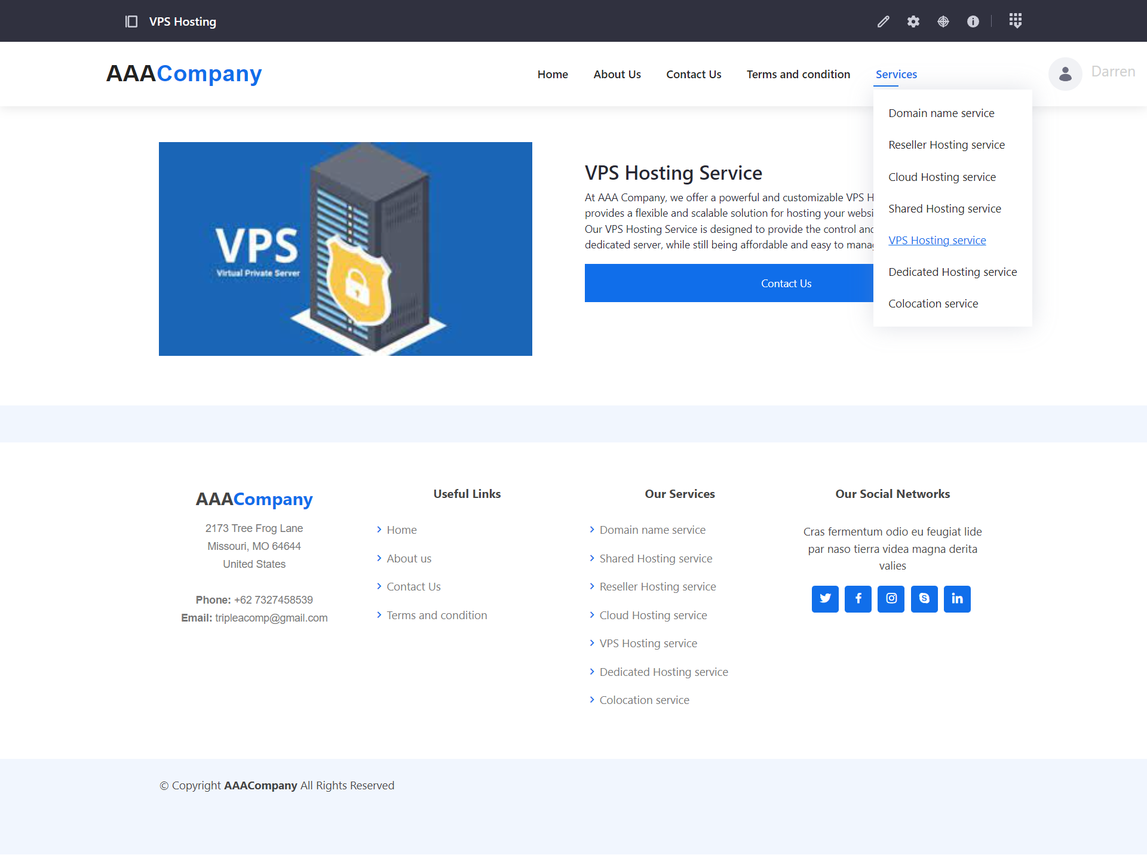

* Dedicated hosting service

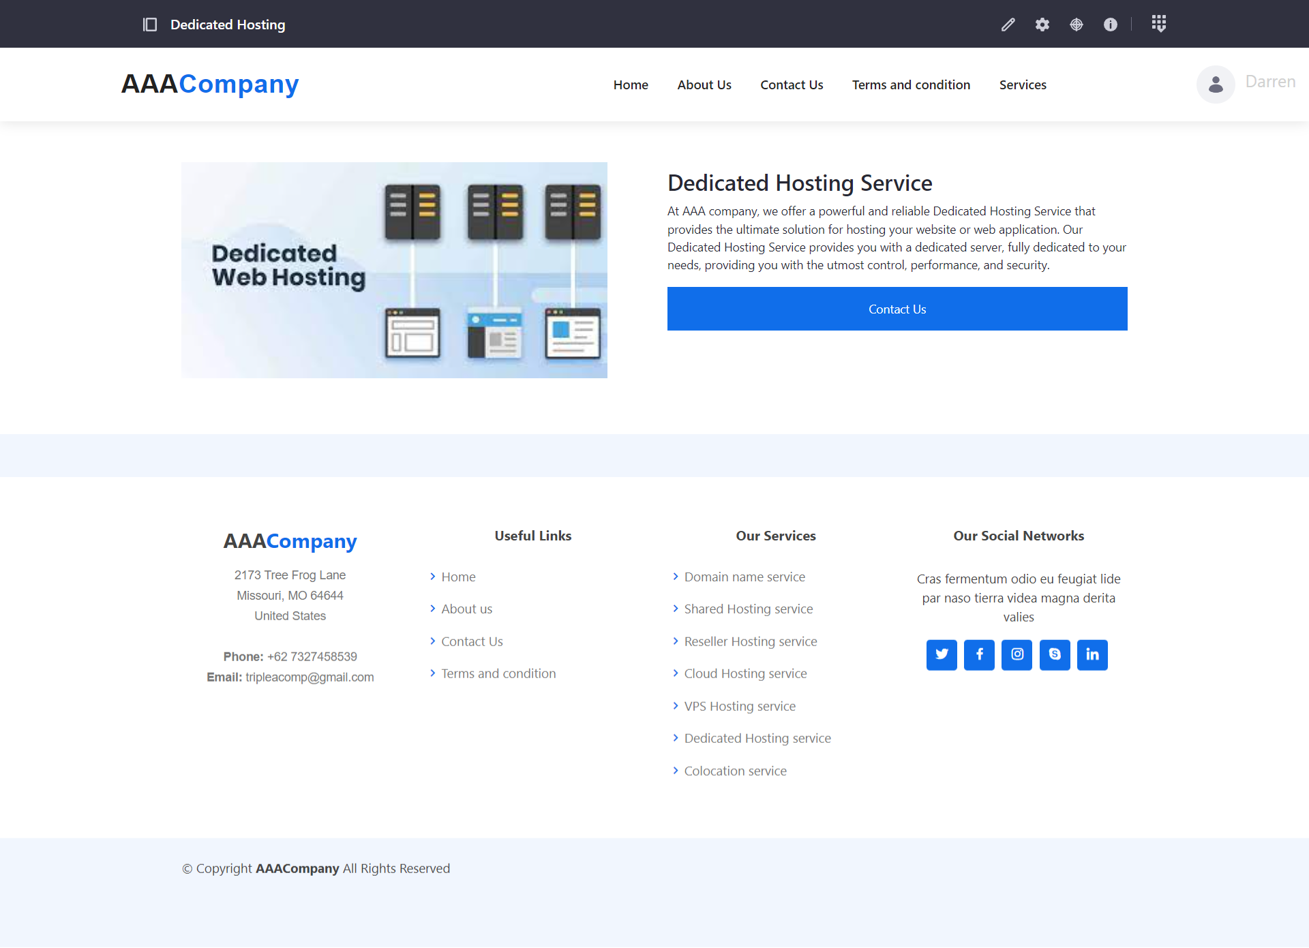

* Colocation service

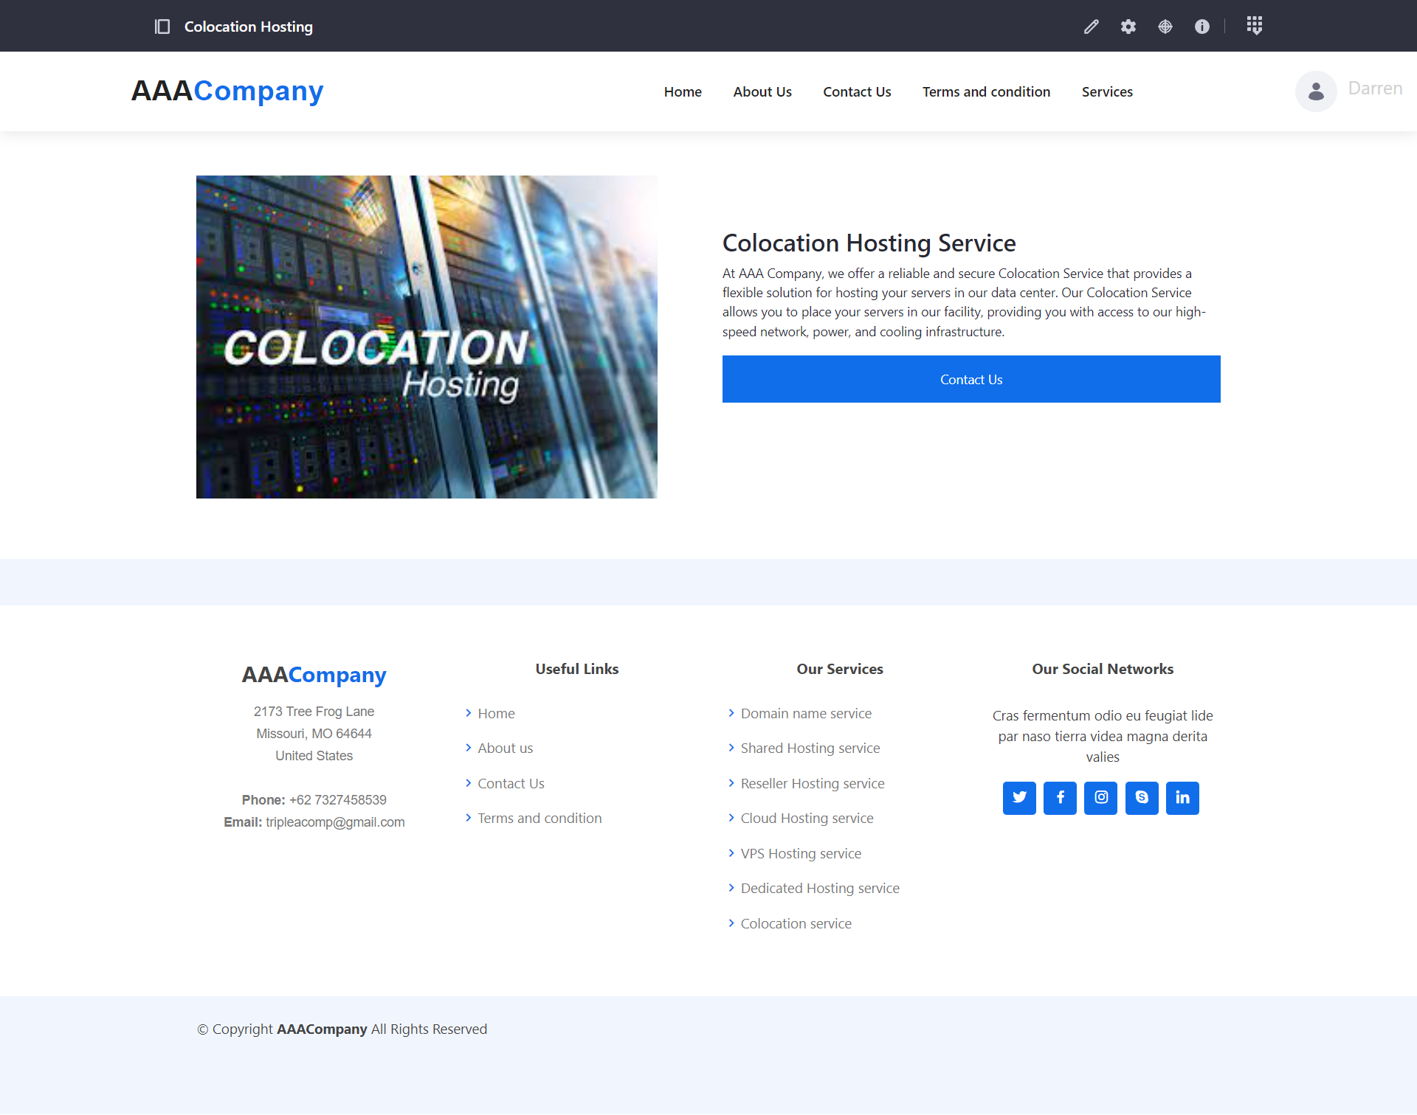

- Customer portlet

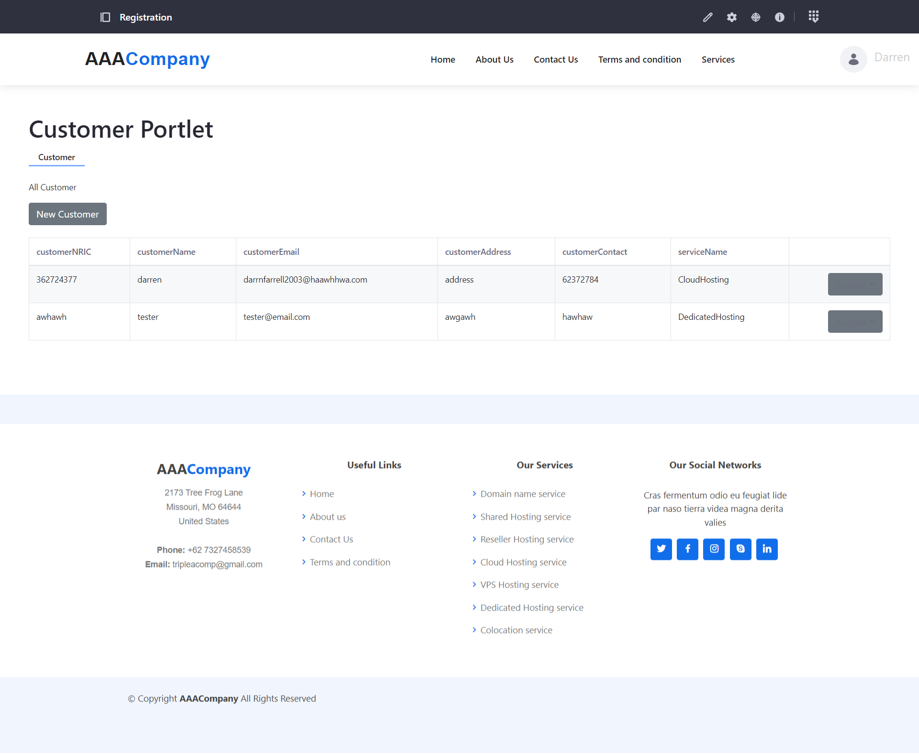

c) Register/Login Page

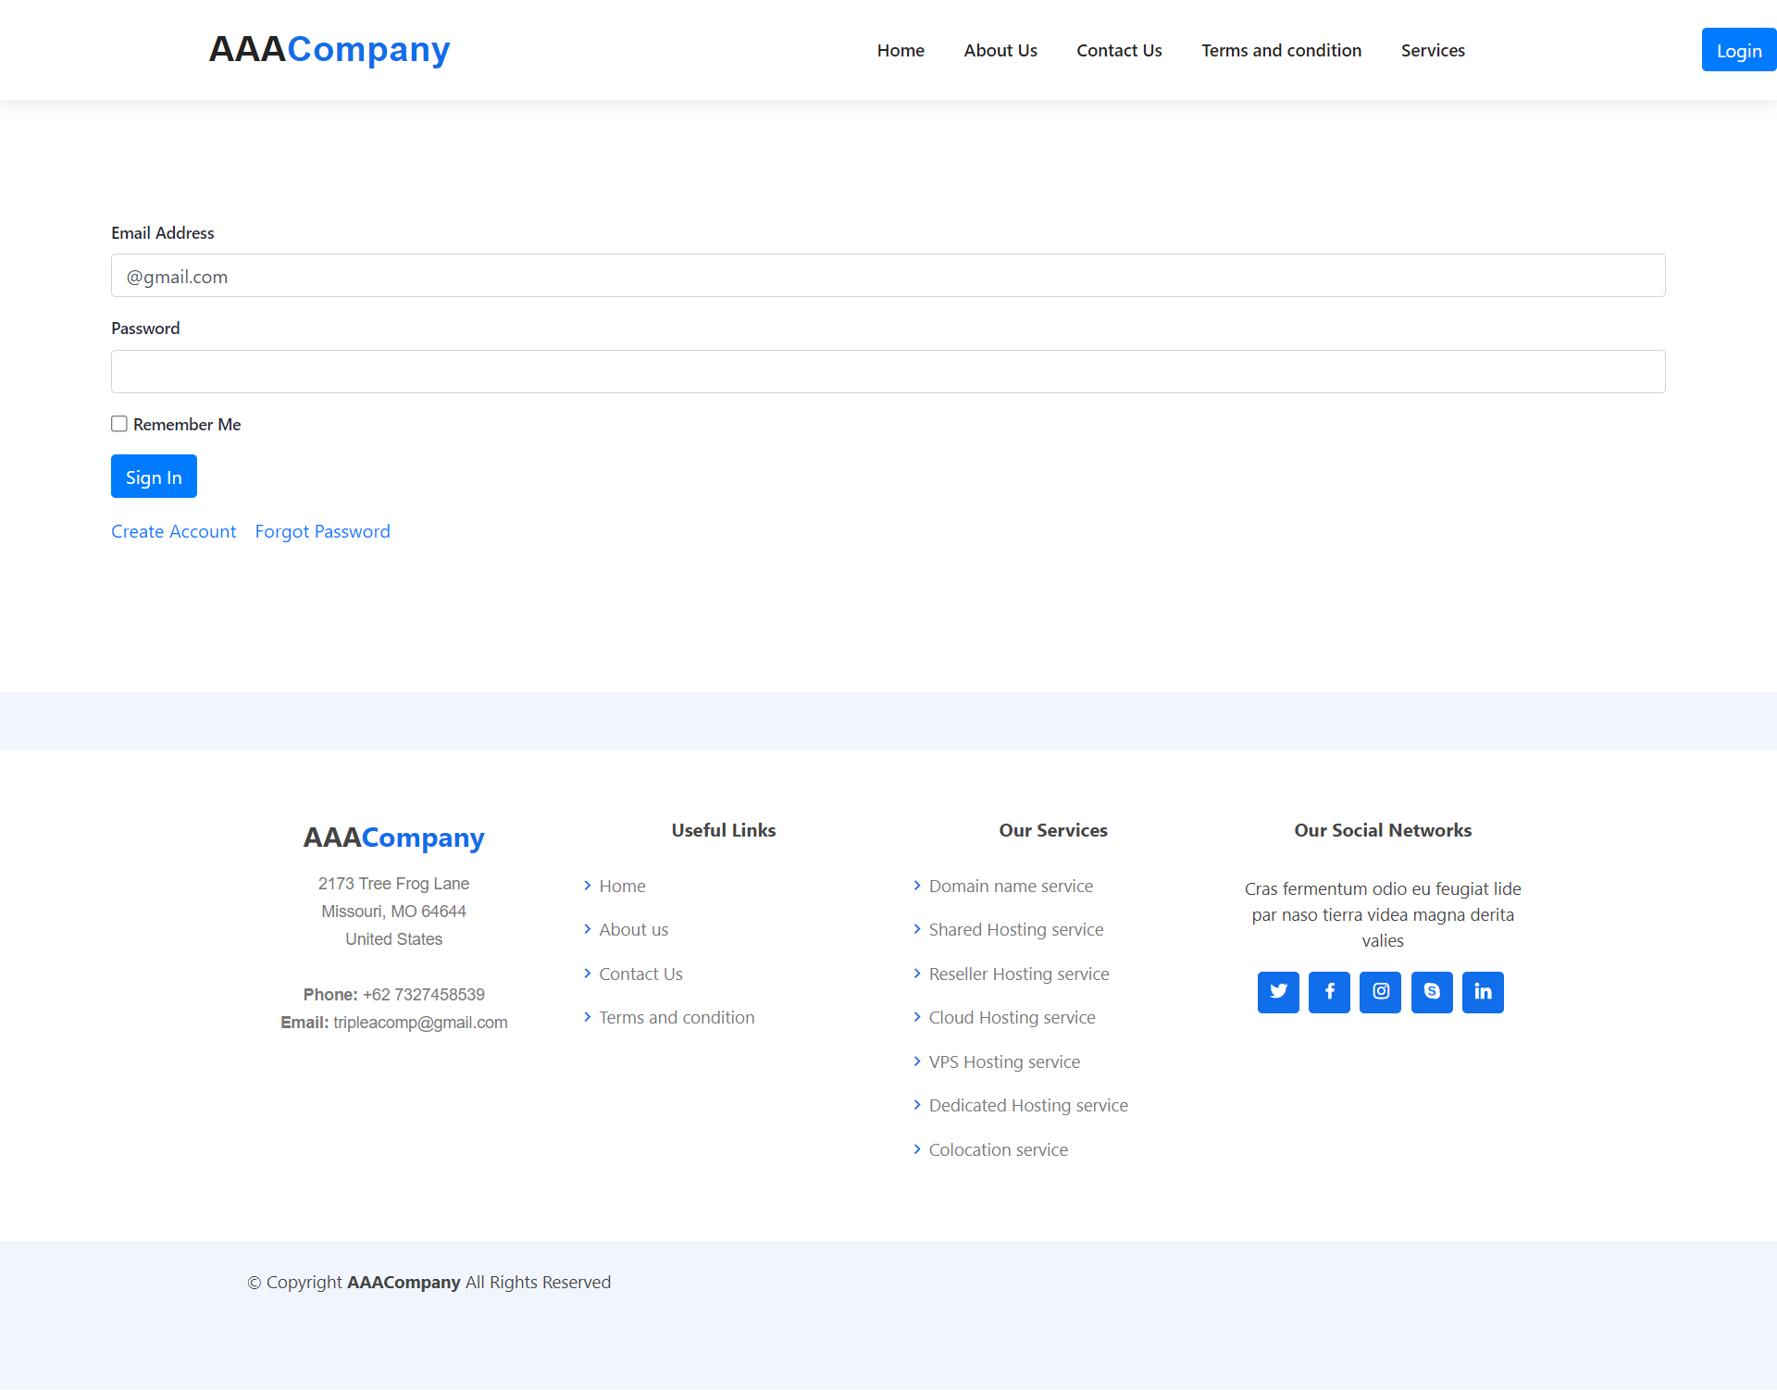

d) Contact Us Page

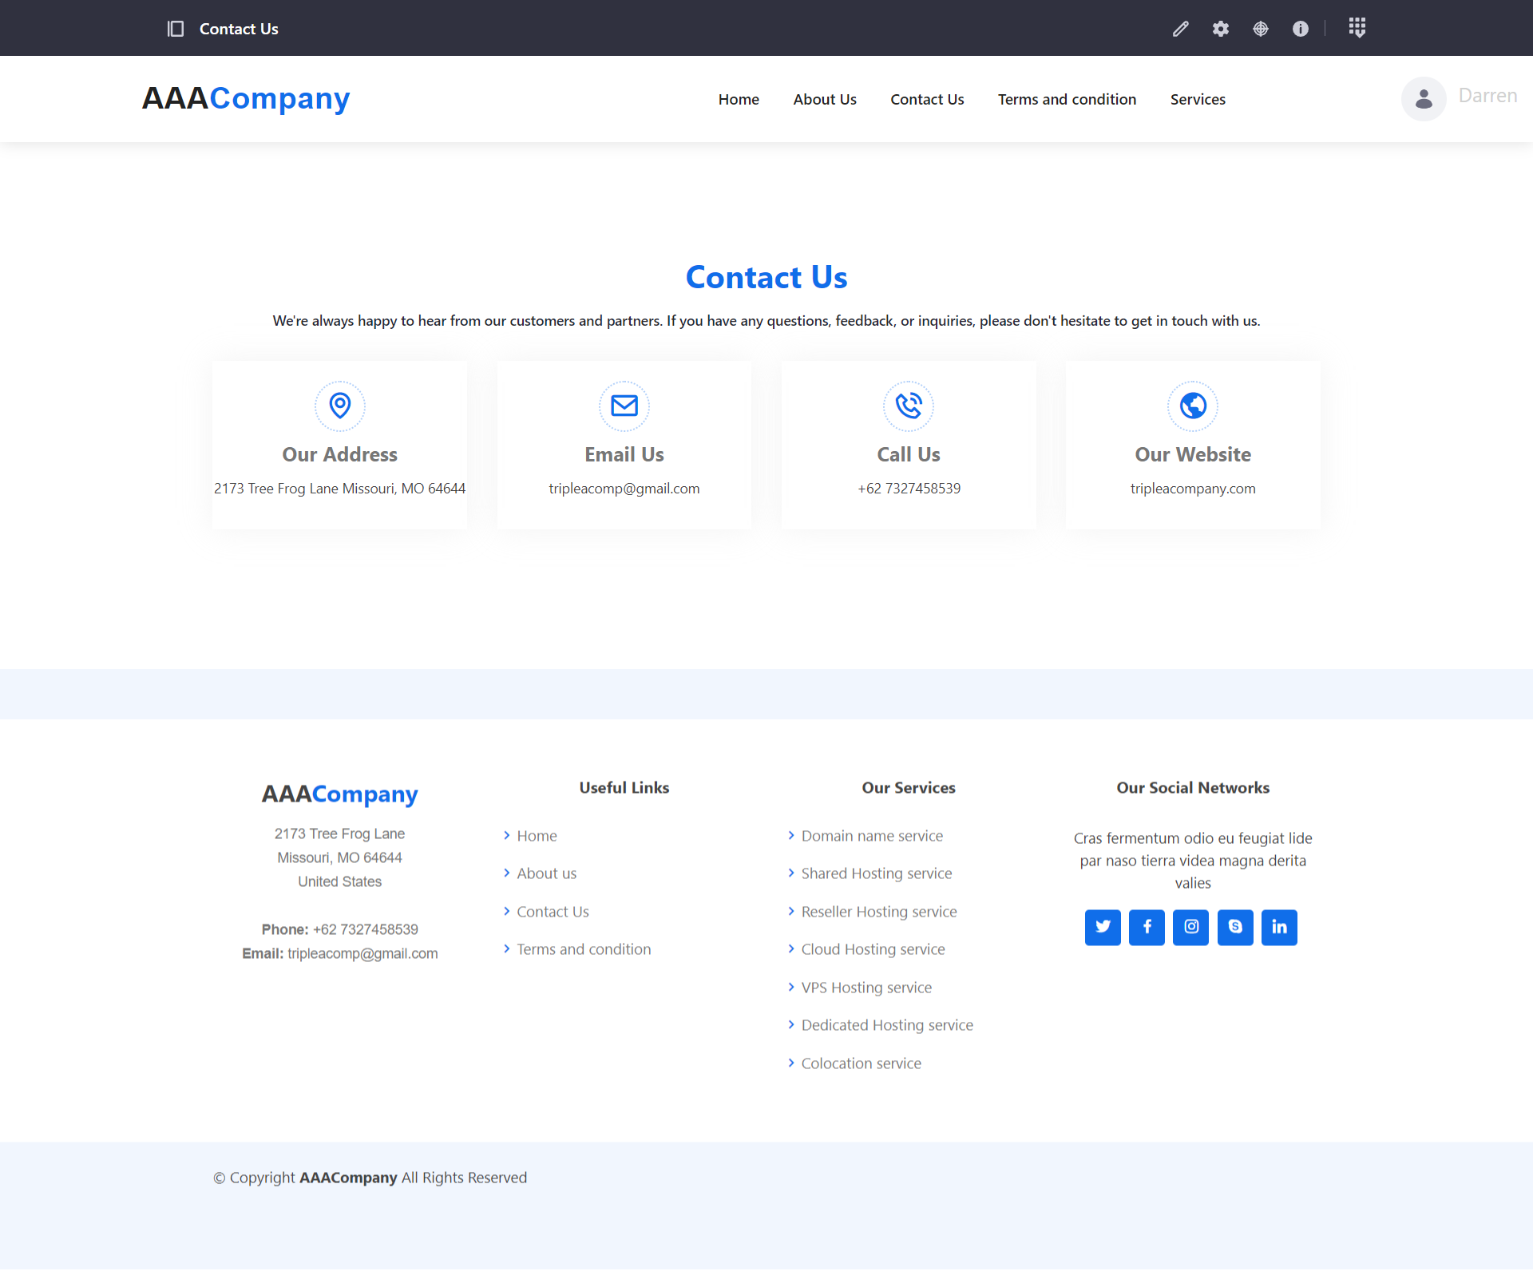

e) About Us Page

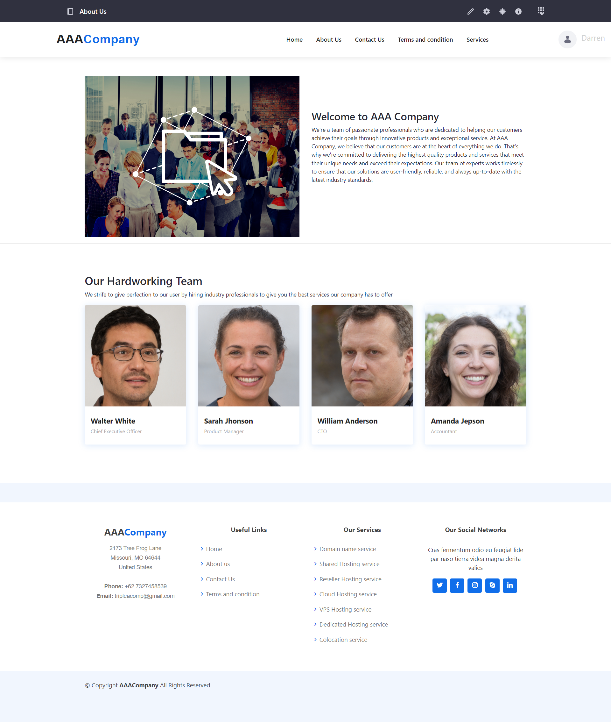

f) Terms and Condition Page

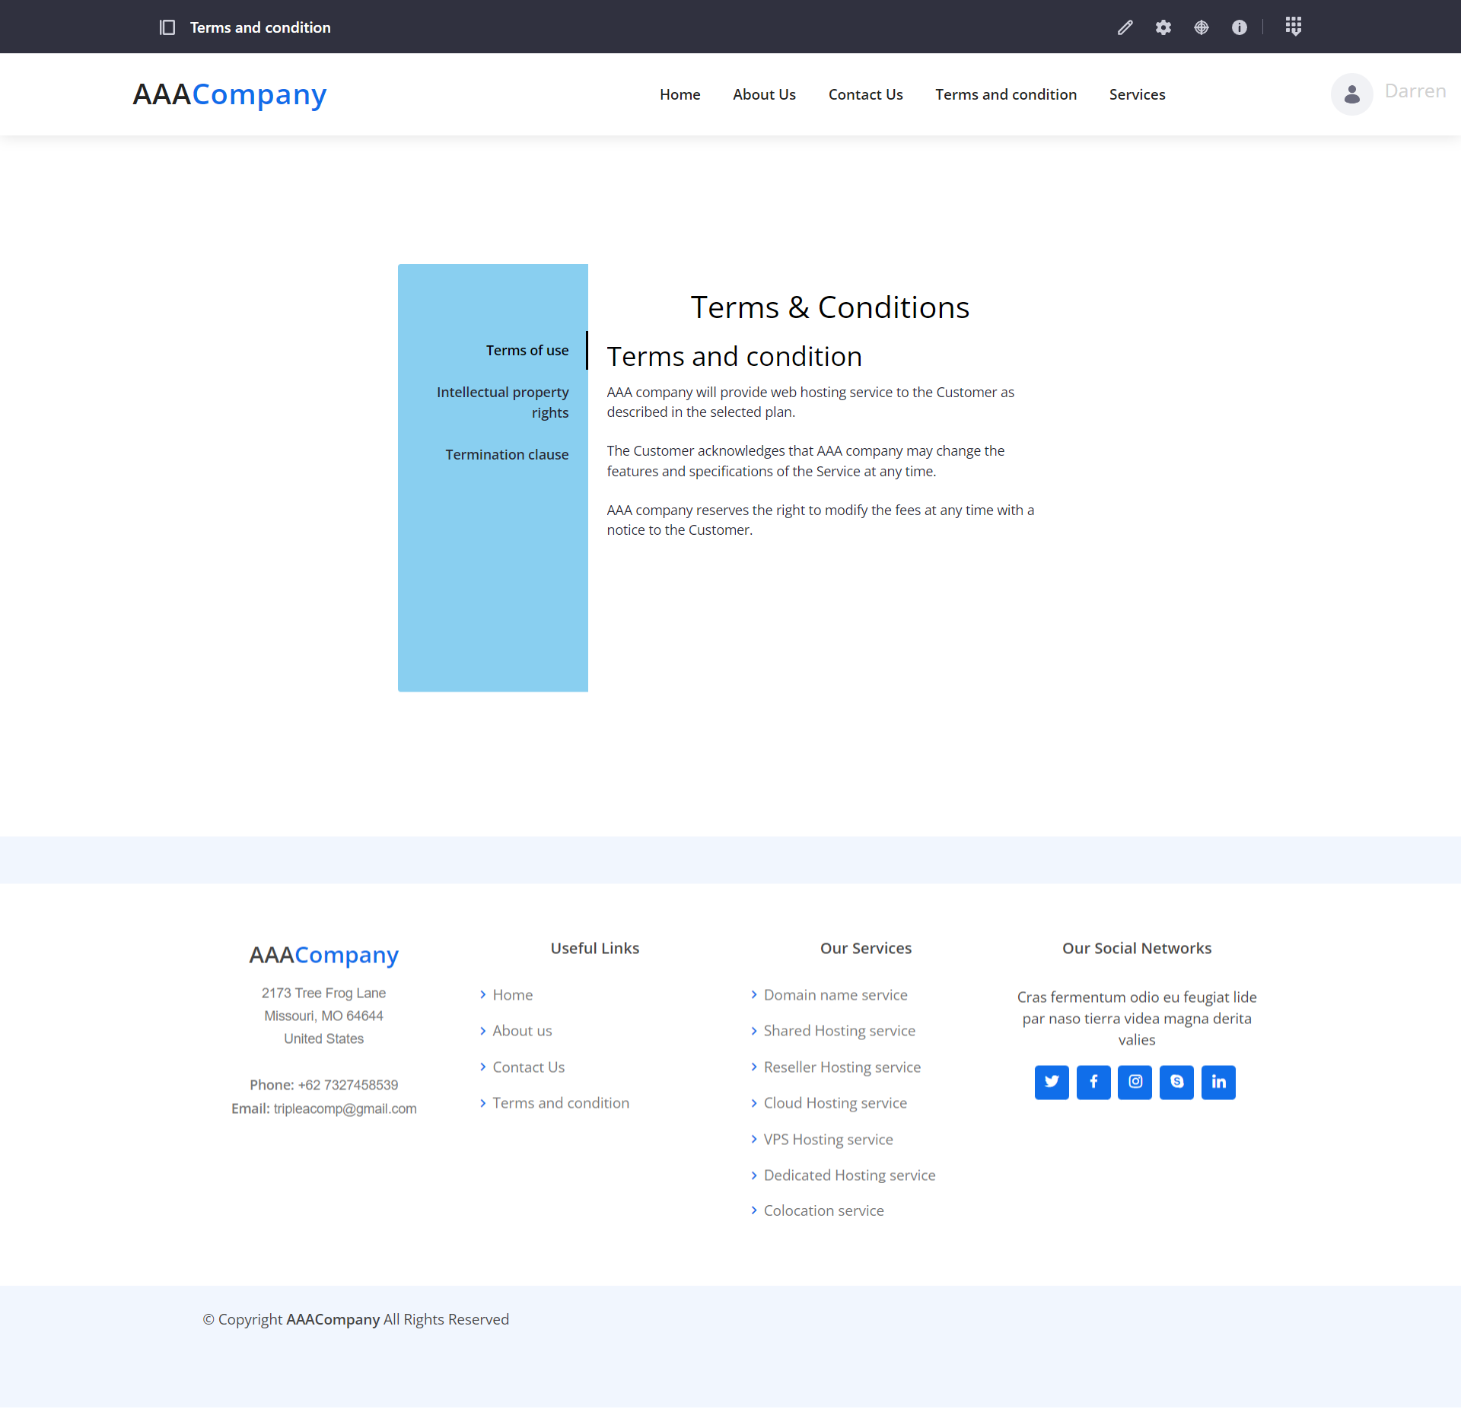

8. Provide screen capture logging in with two different users (Administrator, Site Member) showing Permission for Customer and Service Portlet.

Administrator

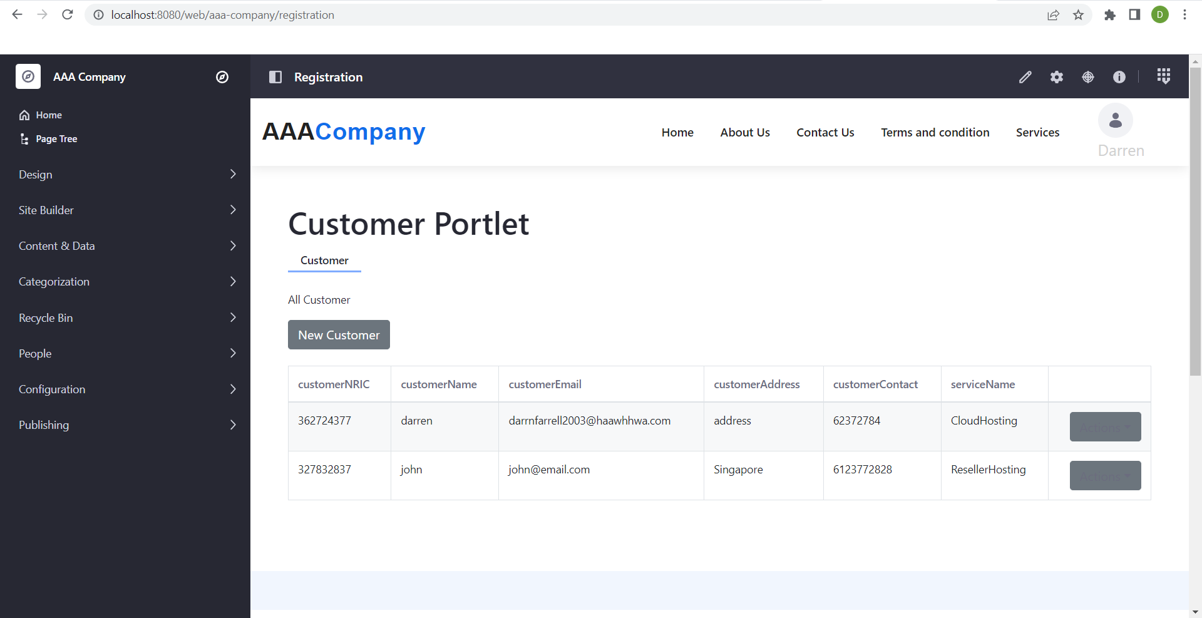

Staff

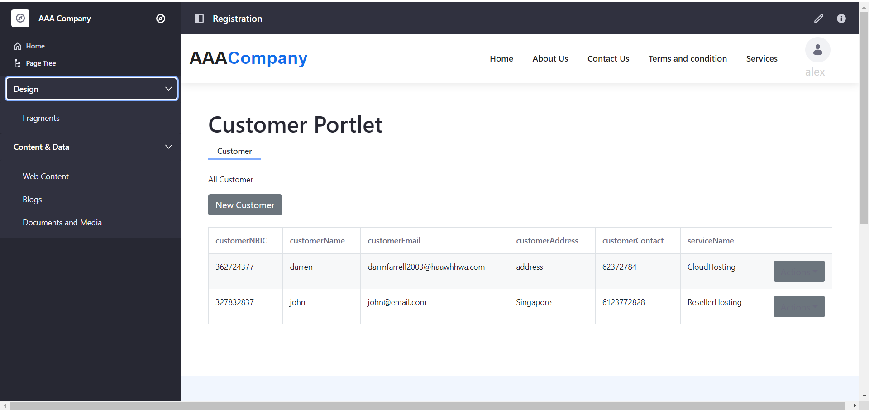

Permission for admin panel

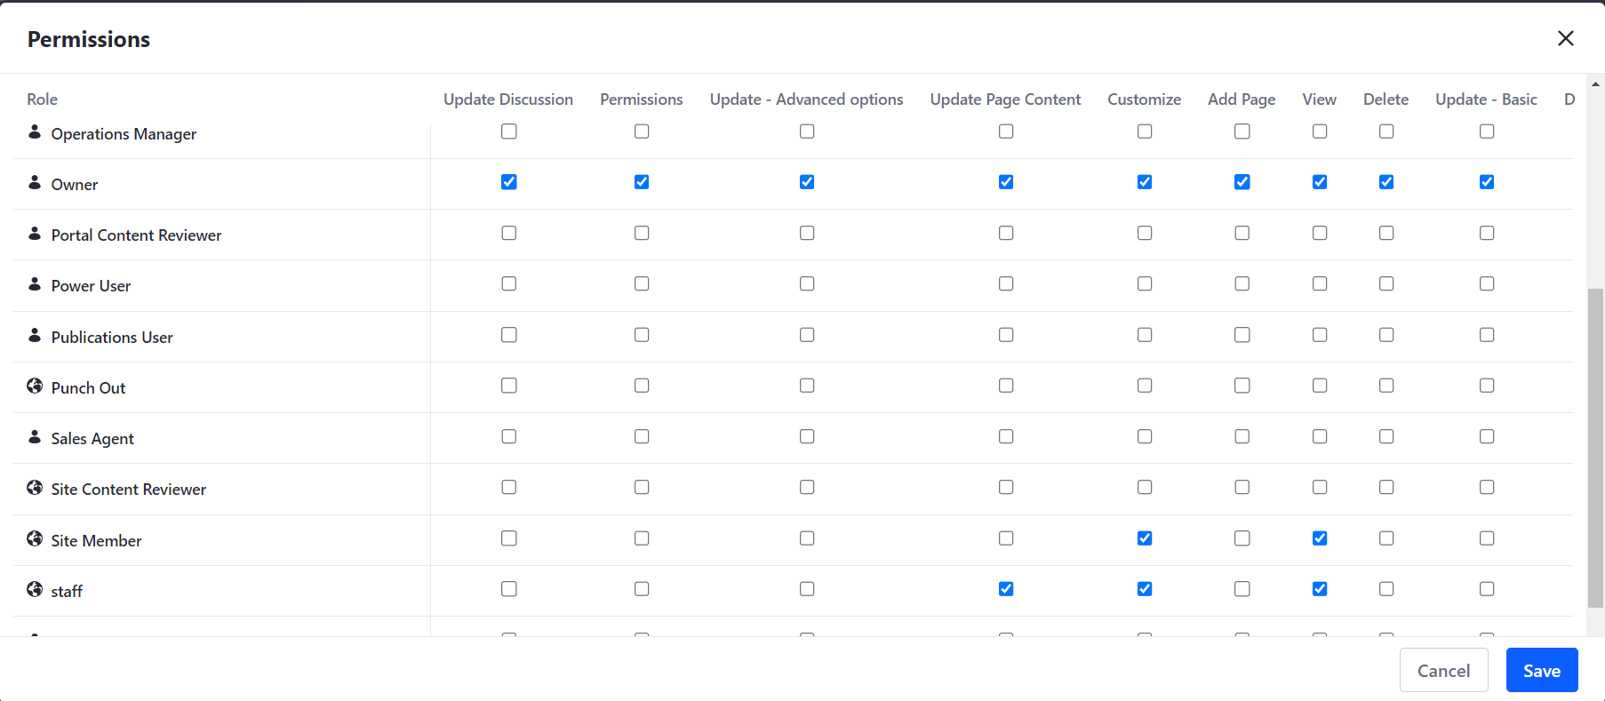

**8. Develop an application that implements design patterns and utilizes techniques to produce secure code. Provide the implemented code as evidence.**

Three important design patterns that were discovered in the system are the factory pattern, facade pattern, and template pattern. The factory pattern leverages polymorphism, which is crucial in the ServiceContextFactory class's getInstance() method implementation.

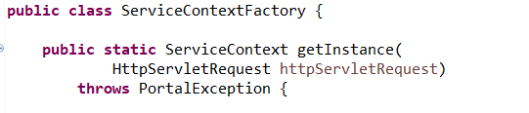

Method invocation statement from CustomerPortlet.java (controller class)



The factory pattern utilizes polymorphism to create the serviceContext object in different forms based on the request object, Customer. Polymorphism provides the benefit of code reuse without impacting the existing code.

The facade design pattern is employed in the CustomerLocalServiceUtil class, which serves as a simplified interface to the complex system it hides. The CustomerLocalService is encapsulated behind a single object, the facade class. Each method in the facade class, such as addCustomer(), calls the getService() function, which returns a reference to the CustomerLocalService object.

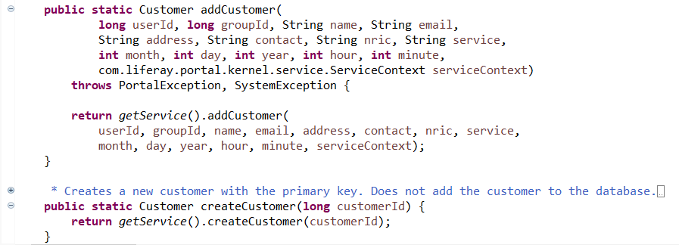

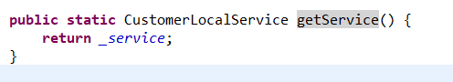

In the facade design pattern, the CustomerLocalService class is the encapsulating class that hides the complexity of the underlying system. By keeping the data members private, the critical data is protected from external access, thereby improving security. The CustomerLocalService interface provides functions such as addCustomer() and deleteCustomer() that encapsulate the business logic or procedures for managing customers. This interface separates the interface's implementation from the underlying system, providing complete abstraction.

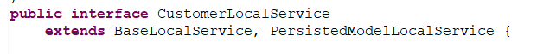



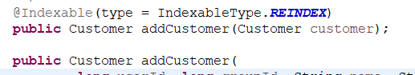



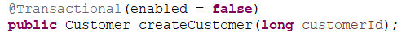

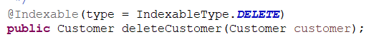

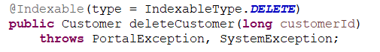

The implementation of an interface by a class, such as CustomerLocalServiceImpl, allows the class to inherit the methods and attributes of the interface's parent class. The implementing class can define the method body and provide specific functionality for the inherited methods.



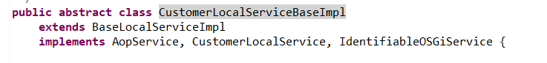

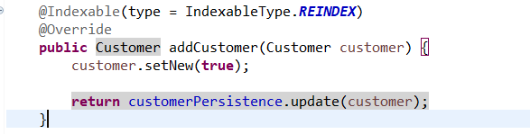

The use of interfaces allows for secure and flexible code, as demonstrated by the possibility of method overriding in implementing classes. Abstraction can also be achieved through the use of abstract classes, such as the Generic Portlet abstract class, which provides default implementations and templates for creating portlets. Subclasses of the abstract class can override methods while maintaining the overall structure and sequence of the parent class, leading to more efficient and reusable code. In the example provided, the CustomerPortlet controller class inherits from the GenericPortlet class using the extends keyword, which in turn uses the MVCPortlet build template. Multi-level inheritance is present as another class has already extended from another class.

Generic portlet implements Portlet, PortletConfig, EventPortlet, ResourceServingPortlet, HeaderPortlet



Liferay portlet extends GenericPortlet

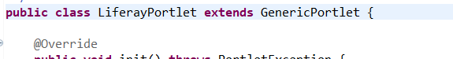

MVCPortlet extends LiferayPortlet

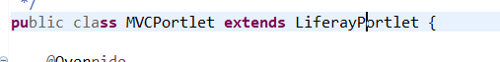

And finally CustomerPortlet extends MVCPortlet



**9. Discuss the use of design patterns for the given purpose and consequences by applying design patterns**

The use of design patterns in software development can have both advantages and disadvantages. In terms of creational patterns, the factory pattern can provide loosely-coupled access to objects and their context information, making it easier for clients to retrieve the information they need without needing to directly instantiate the objects themselves. However, the use of multiple classes in the factory pattern can lead to increased complexity and refactoring difficulties.

On the other hand, structural patterns such as the facade pattern can simplify access to subsystems by providing a single entry point through a facade class. This can help to reduce coupling between components and increase flexibility, but implementing the facade can be a challenging and time-consuming process. Additionally, high dependency on the facade class can introduce risks that may affect the business logic of the system.

Finally, behavioral patterns like the template method pattern can help to reduce boilerplate code by providing a generic structure for building classes. However, the use of a template may restrict the development of specific designs, and maintenance issues can arise if there is a disruption in the high- or low-level classes. Overall, while design patterns can provide benefits in software development, it is important to carefully consider their use and potential drawbacks.

**10. Investigate how different design patterns can work within a range of different scenarios.**

**(Non-BTEC Task 4 - 2)**

**Design Patterns**

**1. Creational Design Pattern**

Factory pattern

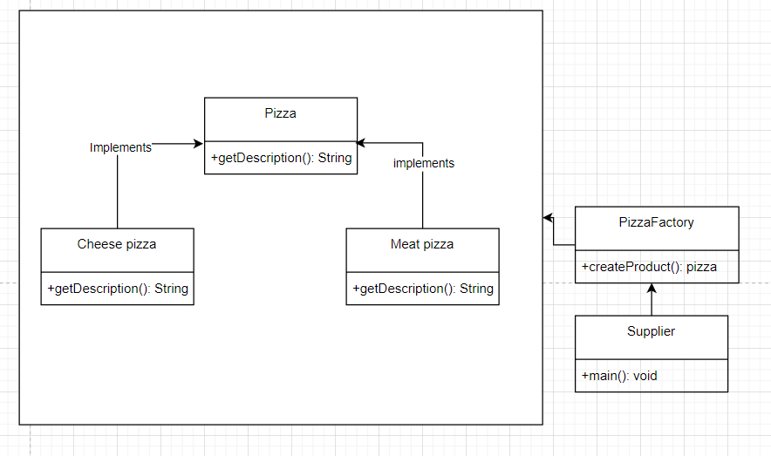

**Scenario:** The pizza factory gets the information on what supply there are to create different types of pizza (meat or cheese pizza). The pizza factory create the pizza which is meat or pizza. Pizza is an interface that is implemented by meat and cheese pizza which all has the same method which is getDescription. But the meat and cheese pizza has different desription because they develop their method on their own classes.

Builder pattern

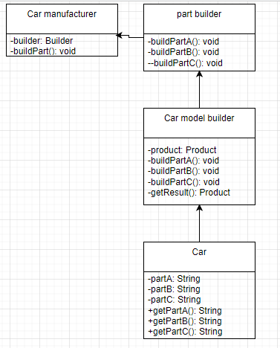

Scenario:

Let's consider a car manufacturing company that offers a build-your-own-car service. The company has different car models, and customers can customize their cars by selecting various options, such as the car color, engine, interior, and other features. The company uses the Builder pattern to build customized cars depending on the specification of the customer.

**2. Structural Design Pattern**

Façade Pattern

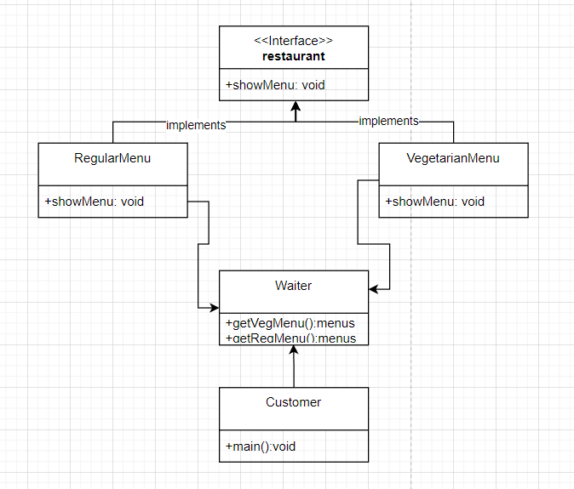

When a customer enters a restaurant and wants to know about the different menus available, the waiter is there to assist. The waiter acts as a facade and hides the complexity of the restaurant's menu system. Through the restaurant's interface, the waiter can retrieve menus and present them to the customer. Behind the scenes, there is a class that maintains a collection of menus and retrieves them upon request. This class is the facade, and it simplifies the process for the waiter, allowing them to focus on providing excellent service to the customer.

adapter pattern

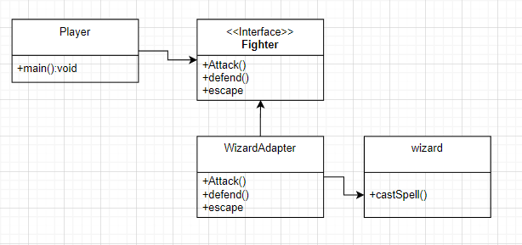

Think of this as a game, the player wants to use the wizard character but the wizard class has a different interface to the fighter interface. To make the wizard compatible with the with the fighter class we create an adapter class that implements the fighter interface to make it usable

**3. Behavioral Design Pattern**

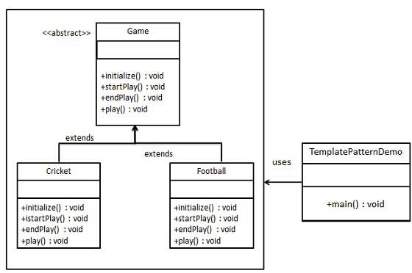Template pattern

Scenario: The game class acts as a template for both of the game that extends it which is cricket and football. Both of the game has all of the method that the parent class has but maybe they have different implementation of said method because both of the game is played differently By using a template method, the common parts of the algorithm are centralized and the specific implementation details can be left to the subclasses to implement. This promotes code reuse and reduces code duplication.

Mediator pattern

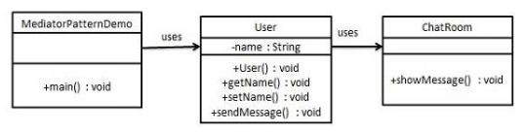

In the scenario of the Mediator pattern, there is a Chat Room that is responsible for broadcasting messages to all users. Users will communicate with each other by utilizing the methods provided by the Chat Room object. To demonstrate the communication between users, the MediatorPattern Demo will utilize User objects.

**11. Identify the appropriate design pattern from the investigation.**

**(Non-BTEC Task 4 - 3)**

**Guidance**

From P4’s investigations, reconcile the most appropriate design patterns from

a range with a series of given scenarios (Given Scenarios mention from P4)

1. Among 2 different scenarios in creational design which you have analyzed in P4, reconcile most appropriate design pattern

The factory design pattern is a creational pattern that provides a loose coupling between the client and the object creation process. This decouples the client code from specific implementation classes and allows any class that implements an abstract class or interface to use the factory method. The subclass can determine which object to create, which is useful when the exact object to be created is unknown. The factory method can also implement polymorphic behavior by creating objects based on data from the client. Overall, the factory design pattern is a useful way to centralize object creation and provide flexibility in object instantiation.

1. Among 2 different scenarios in structural design which you have analyzed in P4, reconcile most appropriate design pattern

The facade design pattern is a structural pattern that allows complex systems to be encapsulated behind a single, simplified interface object. The main purpose of the facade is to provide a straightforward interface for the clients to interact with the system. This way, clients do not need to worry about the complexities of the system, as the facade class hides those details. By providing a unified and easy-to-use interface, the facade pattern improves the usability and maintainability of a system.

c. Among 2 different scenarios in behavioral design which you have analyzed in P4, reconcile most appropriate design pattern

The mediator design pattern is a behavioral pattern that adds a mediator object between communicating objects to reduce coupling and increase flexibility. The mediator object acts as a coordinator between objects, abstracting and centralizing communication between them. It promotes modularity and reusability by allowing objects to communicate without knowing about each other's implementation details, simplifying the interactions between them. The mediator pattern is particularly useful when dealing with a large number of objects that need to communicate in complex way

**12. Evaluate and justify the design patterns that you had identify in each of the scenarios.**

**(Non-BTEC Task 4 - 4)**

Design patterns in software engineering have been developed to solve common design problems that arise when building complex software systems. Creational design patterns address the issue of object creation, where classes can delegate the task of creating objects to subclasses using a factory method. This approach allows for the creation of new products that share common interfaces and can be managed by the subclass. An example of a system that benefits from this technique is an authentication system with varying authentication processes based on user authorization levels.

Structural design patterns are focused on how classes and objects can be organized to form larger structures. One such pattern is the facade pattern, which simplifies a complex system by providing a single interface for the underlying subsystems. The facade class can delegate functionality to the subsystems, hiding their complexity and promoting loose coupling. This approach is beneficial for systems that need to be flexible and adaptable to changing requirements.

Behavioral design patterns, such as the mediator pattern, manage the communication between objects to promote loose coupling. The mediator pattern routes communication between objects through a mediator, preventing direct communication and allowing for more manageable code. This pattern is useful for managing many objects that interact with one another, such as in a messaging system.